

**DATA ANALYSIS IN BUSINESS**

**CONTENT: REPORT LAB 2**

Ho Chi Minh City, March 2022

**VIETNAM NATIONAL UNIVERSITY HO CHI MINH CITY**

**UNIVERSITY OF INFORMATION TECHNOLOGY**

**FACULTY OF INFORMATION SYSTEM**

———h&g———

**CLASS: IS211.M11.HTCL**

**TEAM: 3**

**STUDENTS:**

TRẦN MẪN QUÂN 19520873

ĐẶNG NGUYỄN PHƯỚC AN 19521171

TRẦN THỊ NGỌC AN 19521189

**TABLE OF CONTENT**

WORK ASSIGNMENT TABLE 2

I. EXERCISE 2A 3

II. EXERCISE 2B 7

1. R 7

2. PYTHON 10

3. Excel 14

III. EXERCISE 2C 18

1. R 18

2. Python 20

3. MS EXCEL 23

IV. EXERCISE 2D 25

1. R 26

2. PYTHON 30

3. Excel 33

V. EXERCISE 2E 38

1. R 38

2. Python 40

3. MS EXCEL 43

VI. EXERCISE 2F 43

1. R 44

2. PYTHON 47

3. Excel 50

VII. EXERCISE 2G 55

1. R 55

2. Python 57

3. MS EXCEL 60

REFERENCES 61

WORK ASSIGNMENT TABLE

|  |  |  |  |  |
| --- | --- | --- | --- | --- |
| **No.** | **Student’name** | **Student’s ID** | **Assignment** | **Evaluation(%)** |
| 1 | Trần Mẫn Quân | 19520873 | - Doing Ex 2A  - Finding datasets for 2G  - Writing problem statements and formating final report | 100% |
| 2 | Đặng Nguyễn Phước An | 19521171 | - Doing Ex 2D, 2E, 2F  - Finding datasets for 2F  - Presenting | 100% |
| 3 | Trần Thị Ngọc An | 19521189 | - Doing Ex 2B, 2C, 2G  - Writing raw report, conclusions | 100% |

1. EXERCISE 2A

ANOVA (Analysis of Varience) is used to compare the means of two or more population groups. Levene's test is the first step taken before ANOVA, and the Tukey test is done after the ANOVA.

**Levene’s Test:** is used to test if k samples have equal variances. Equal variances across samples is called homogeneity of variance. This is the condition to decide whether to perform ANOVA test or not through 2 hypotheses:

H0:Variances between k groups are equal (σ12 = σ22 =…= σk2)

H1: Variances between k groups are not equal (σi2 ≠ σj2   for at least one pair (i,j))

The Levene’s test statistic is defined as: W= $\frac{(N-k)\sum_{i=1}^{k}{Ni}(\overline{Z}i.-\overline{Z}..)2}{(k-1)\sum_{i=1}^{k}{\sum_{j=1}^{Ni}{(Zij-\overline{Z}i.)2}}}$

We can calculate W and then compare with *Fα*,*k*-1,*N-k* which is the[upper critical value](https://www.itl.nist.gov/div898/handbook/eda/section3/eda3673.htm) of the [F distribution](https://www.itl.nist.gov/div898/handbook/eda/section3/eda3665.htm) with k-1 and N-k degrees of freedom at a significance level of α. If W > *Fα*,*k*-1,*N-k* then reject H0, otherwise, accept H0

In another way, we can compare p-value with α. If p-value < α, then reject H0, otherwise, accept H0 (The p-value can be ascertained from the output in R)

When H0 is accepted (meaning equal variances across samples) 🡪 We can do ANOVA test.

**Example of Levene’s Test:** The dataset below uses samples from 30 different plants to know if three different fertilizers lead to different levels of plant growth. They randomly select 30 different plants and split them into three groups of 10, applying a different fertilizer to each group. At the end of one month they measure the height of each plant.

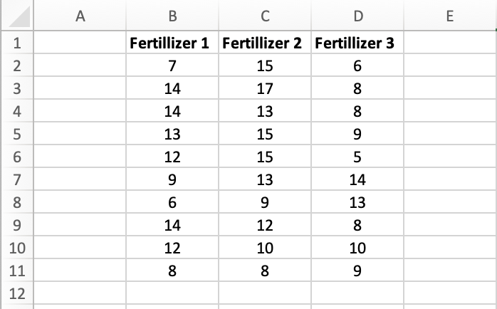

Before they do ANOVA test to determine if there is a difference in plant growth between three groups, they first want to perform Levene’s Test to determine whether or not the three groups have equal variances.

*H0: σ12 = ... = σ102*

*H1: σ12 ≠ ... ≠ σ102 for at least on pair*

* Test statistic: W = 0,535701
* Degrees of freedom: k-1 = 3-1 = 2
* N-k = 30-3 = 27
* Significance level: α = 0.05
* Critical value (upper tail): Fα, k-1, N-k = 3,354

We can see that W < 3,354 🡪 we fail to reject H0. In other words, we don’t have sufficient evidence to say that the variance between the three groups is different.

So next we can do ANOVA test. Suppose we perform a one-way ANOVA on three groups above. The results of the one-way ANOVA are shown below:

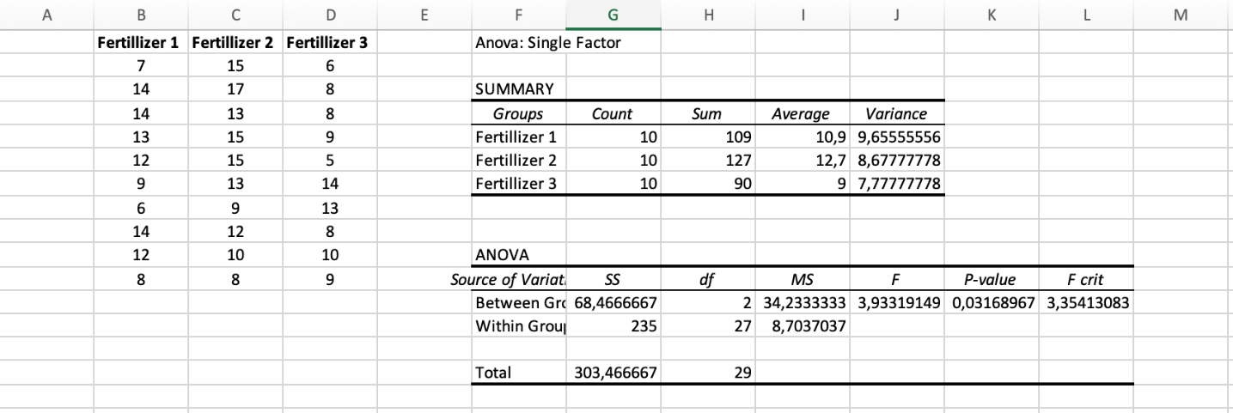

The p-value from the ANOVA table is **0.03168967**. Since this p-value is less than 0.05, we can reject the null hypothesis and conclude that the means between the three groups are not equal.

Now we can perform a **Tukey-Kramer** post hoc to determine exactly which group means are different. Tukey method applies simultaneously to the set of all pairwise comparisons {μi−μj}.

In **Tukey’s method**, we need to calculate two types of value: the mean difference between each group and the Q critical value. When mean difference of any group larger than Q, then this group is significantly different.

Q critical value using the following formula: Q critical value = Q*√(s2pooled / n.)

where:

* Q = Value from Studentized Range Q Table
* s2pooled = Pooled variance across all groups
* n.  = Sample size for a given group

**Example of Tukey’s test**: The s2pooled can be calculated as the average of the variances for the groups, which turns out to be **8.7037037.** The sample size for each group is **10**.

To find the Q value, we can refer to the Studentized Range Q Table which looks like this:

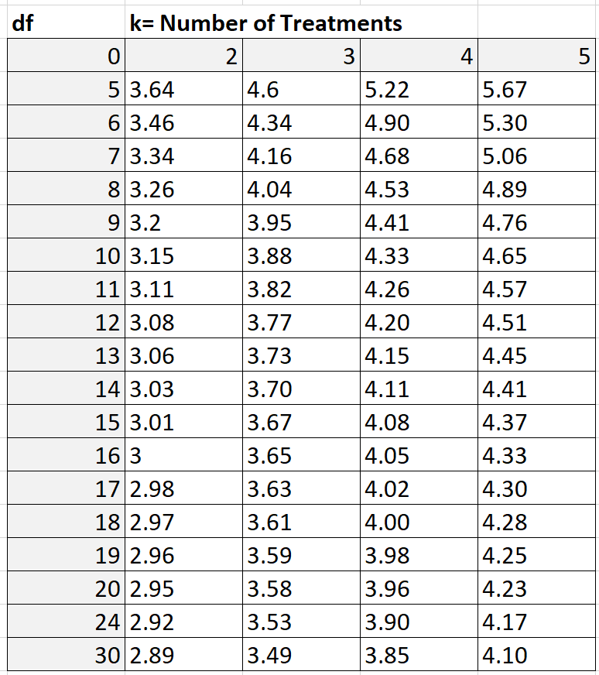

In our example about three fetillizers, k = 3; n – k = 30 – 3 = 27. Since 27 is not shown in the table above, we can use a conservative estimate of 24. Based on k = 3 and df = 24, we find that Q = **3.53**

Thus, Q critical value = Q*√(s2pooled / n.) =  3.53*√(8.7037037/10)  = **3.293**

The result of Tukey’s test on the dataset above is shown on following image:

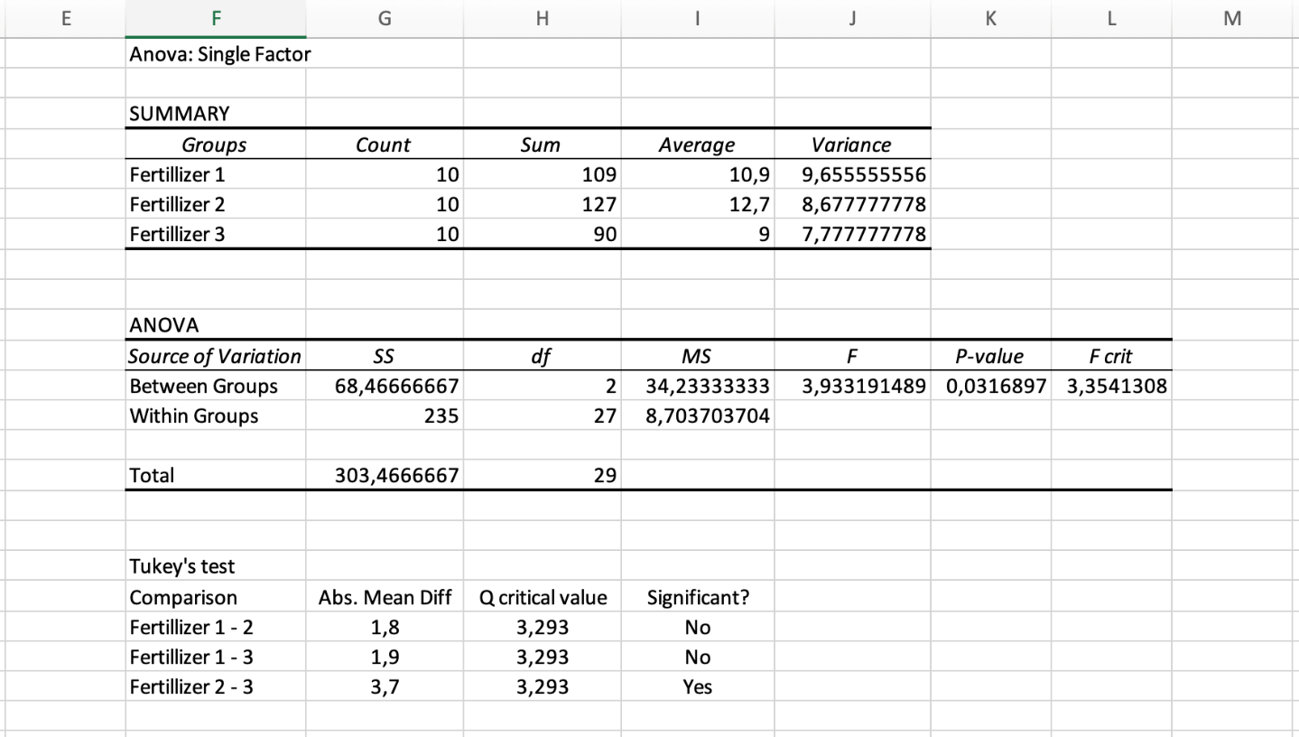

Based on the Tukey’s test, we can conclude that:

* The difference in means between fetillizer 1 and fetillizer 2 is *not* statistically significant.
* The difference in means between fetillizer 1 and fetillizer 3 is *not*statistically significant.
* The difference in means between fetillizer 2 and fetillizer 3 is statistically significant.

1. EXERCISE 2B

**Problem statement:** This is a survey on satisfaction with insurance services collected from 25 students. These students are divided into three main groups of education level: college graduate, graduate degree and some colleges. The analysis aims to find out whether the level of satisfaction affected by education level.

Hypothesis for ANOVA test:

*H0: The level of satisfacion is the same at all education level (μ1 = μ2 = μ3)*

*H1: at least one education level is different from the others*

* 1. R

**Step 1:** Convert **Insurance Survey.xlsx** file to **Insurance Survey.csv**. Select *CSV format like the picture below



**Step2:**

* Import file *csv in step 1 into RStudio Application

ins_lab <-read.csv('Insurance Survey.csv', header = TRUE)



* Attach this file

attach(ins_lab)



**Step 3:** Then, we have to install and use library **car.**

install.packages("car")



* In tab Packages, select **Install**



* Enter the library name, then click **Install**

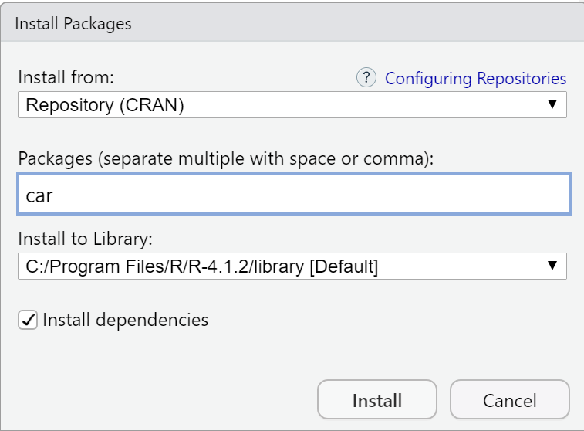

* After the installation is complete, we use the **require()** statement to use the library

require(car)





**Step 4:**

* After using the library successfully, we start calculate the Levene test through the command

leveneTest(Satisfaction.,Education,center="mean")

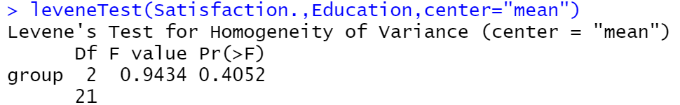

Since Pr (>F) > 0.05 (0.4052 > 0.05) 🡪 Reject H1

* All variances are equal and we can test ANOVA
* Look up: use function **qf** to calculate

qf(p=0.95,2,21)

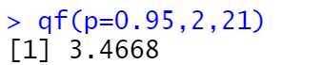

F value < F-Critical (0.9434 < 3.4668) 🡪 Reject H1

* All variances are equal and we can test ANOVA

aov(Satisfaction. ~Education, data = ins_lab)

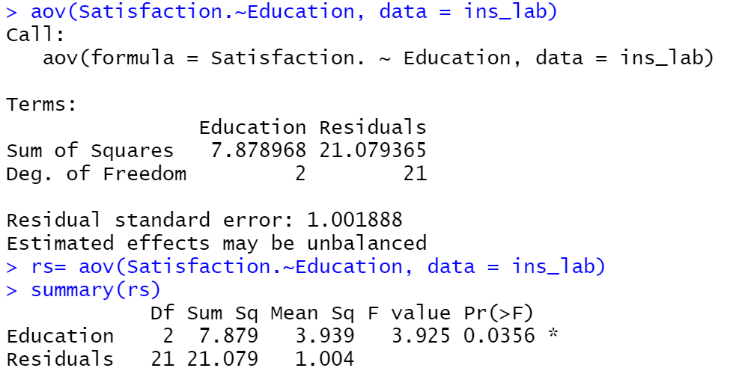

Using α = 0.05 ,Pr (>F), p value = 0.0356 < 0.05 🡪 Reject H0, at least one mean is different from the others

**Step 5:** Calculate the Tukey

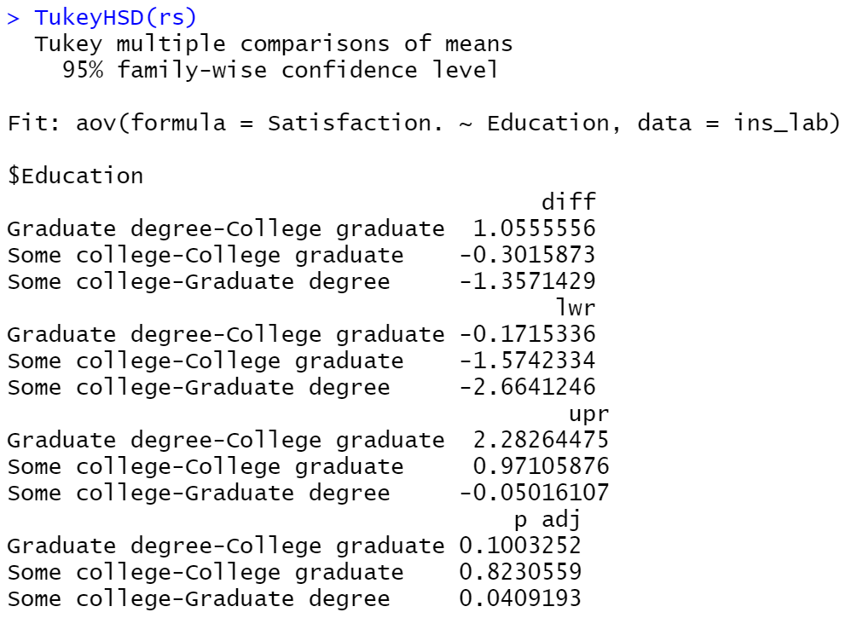

With α = 0.05, Graduate degrre different from the other two groups (P-adj = 0.0409 < 0.05) => Reject H0, at least one mean is different from the others.

* 1. PYTHON

**Step 1:** Open Jupyter notebook

* Go to the folder containing the file **Insurance Survey.csv** and open **cmd**



* Enter the command “jupyter notebook”

jupyter notebook

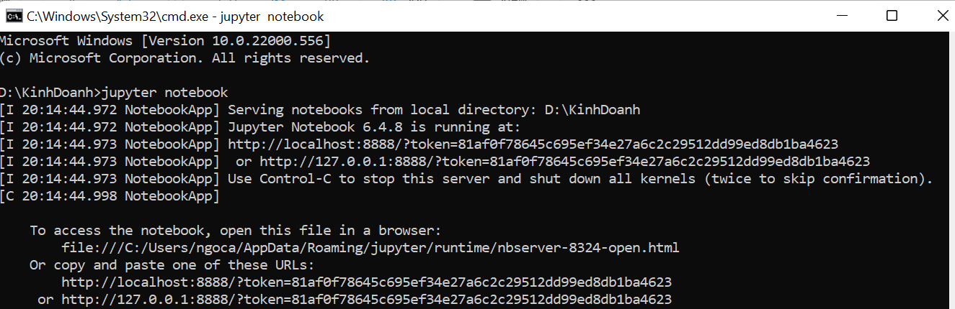

* Access the output link in the cmd



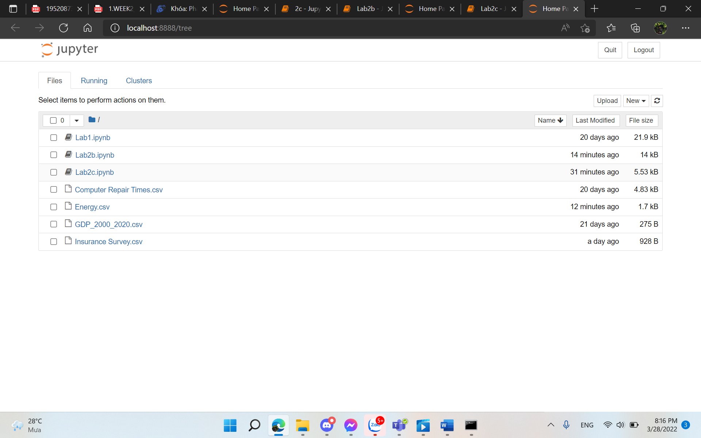

**Step 2:** Create new Python file

* Select the button **New** and click **Python 3** to create a new file

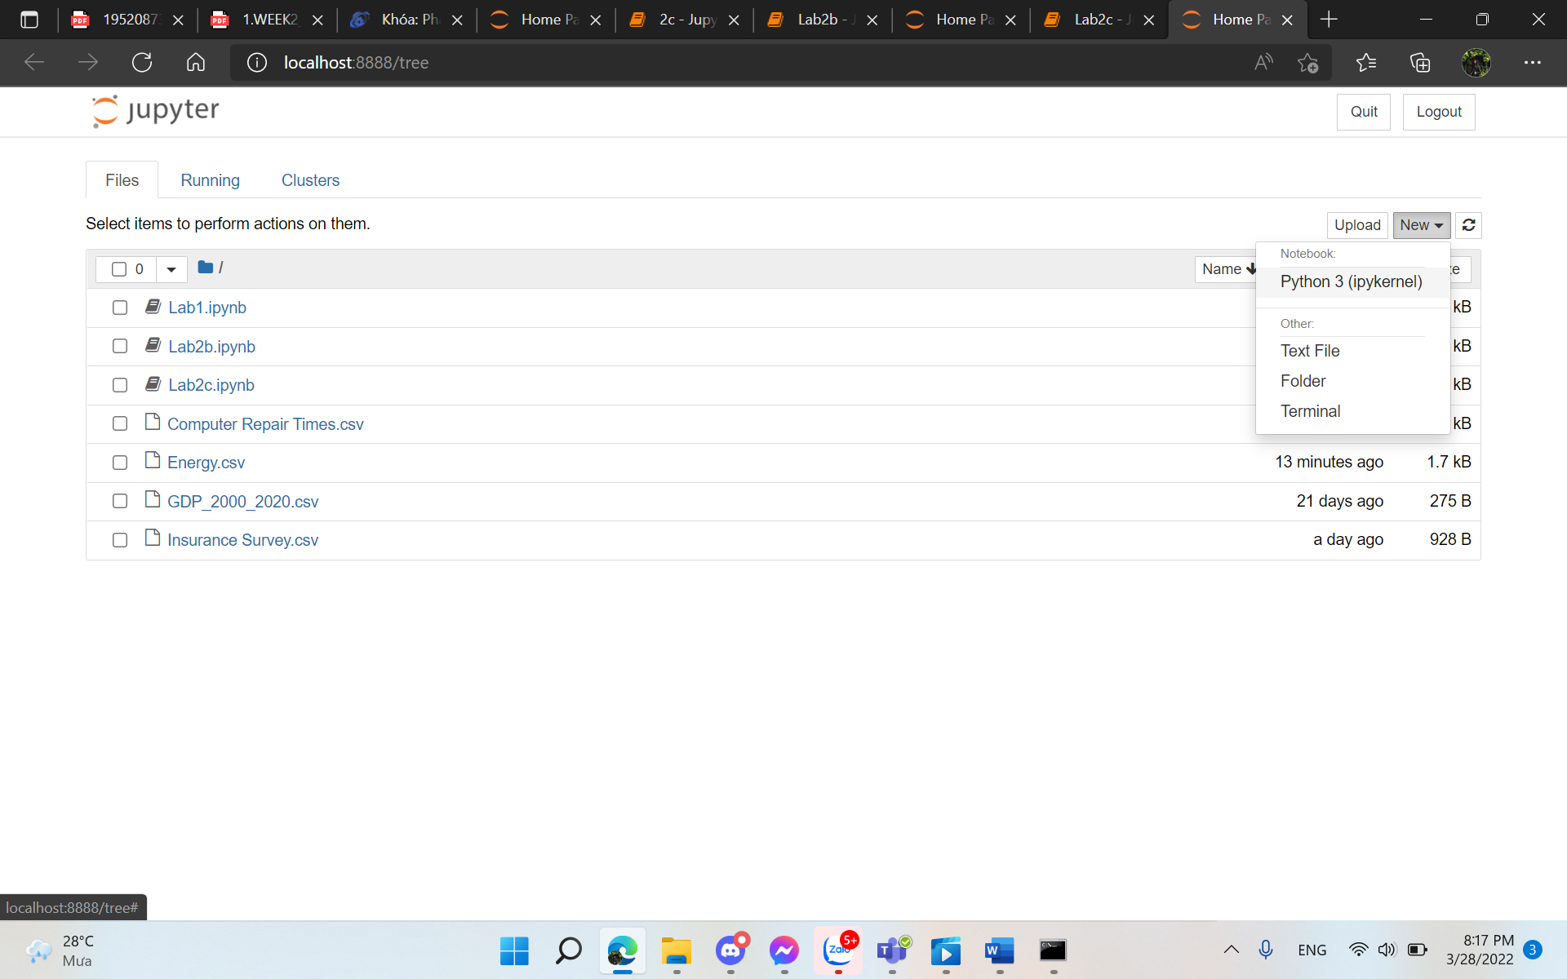

**Step 3:** Import library

import pandas as pd

**Step 4:** Import **Insurance Survey.csv** into the Jupyter

ins_lab = pd.read_csv("Insurance Survey.csv")



**Step 5:** Group data into group function

df2 = ins_lab.groupby('Education')['Satisfaction* '].apply(list)

print (df2)

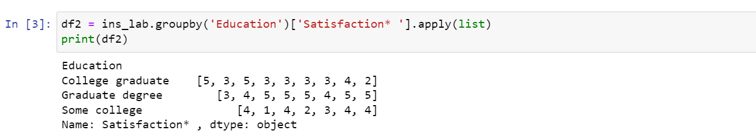

**Step 6:** Import library

from scipy.stats import levene



**Step 7**: Use Python’s Levene function to check determined Levene



p-value > 0.05 (0.405 > 0.05) 🡪 Reject H1, all variances are equal and we can test ANOVA

**Step 8:** Import library

import scipy.stats as stats

fvalue, pvalue = stats.f_oneway(*df2)

print(fvalue,pvalue)

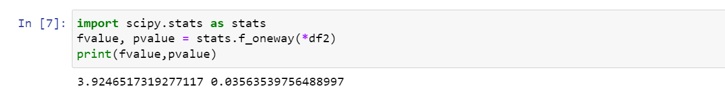

p-value < 0.05 (0.03 < 0.05 ) => Reject H0, at least one mean is different from the other, we can test Turkey

**Step 9:** To use the Turkey function, we start **install statsmodels**

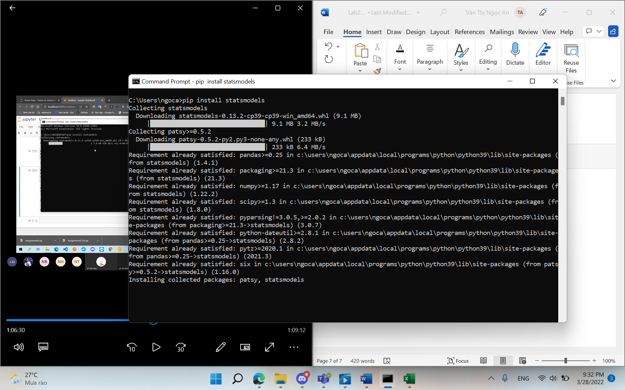

**Step 10:** Calculate Tukey values

from statsmodels.stats.multicomp import pairwise_tukeyhsd

tukey = pairwise_tukeyhsd(endog=ins_lab['Satisfaction* '],groups=ins_lab.Education,alpha=0.05)

print(tukey)

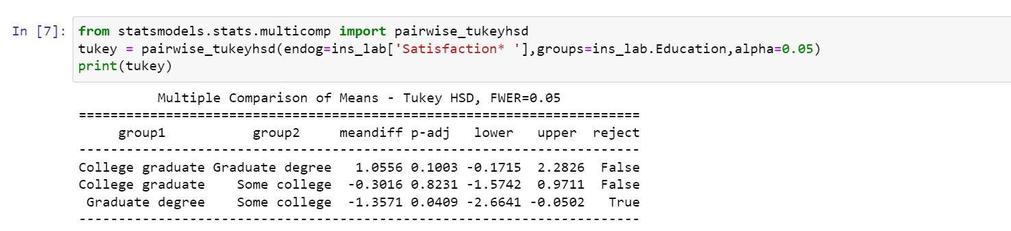

With α = 0.05, Graduate degree different from two other groups (P-adj = 0.0409 < 0.05) 🡪 Reject H0, at least one mean is different from the others.

* 1. Excel

**Step 1:** Do Levene’s test

* Calculate the mean of each group

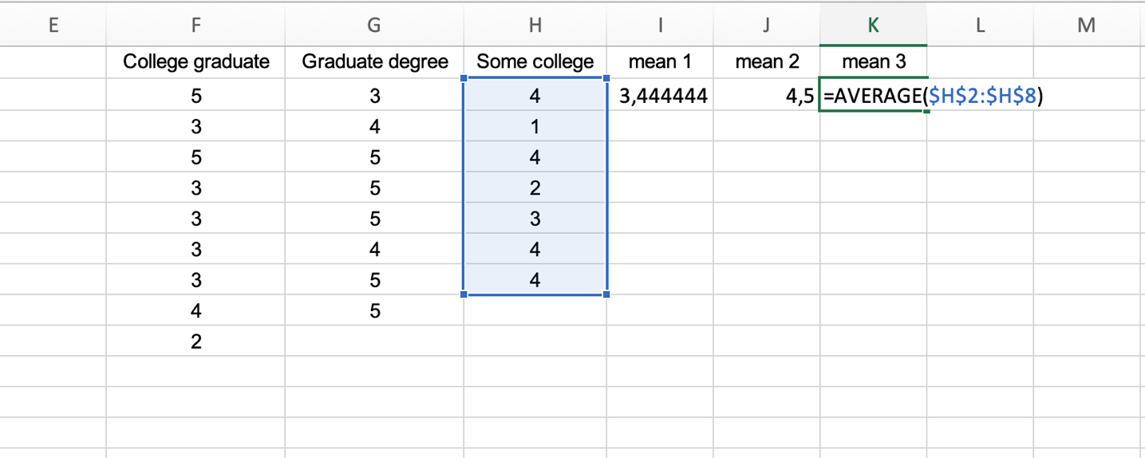

* Calculate the absolute residual

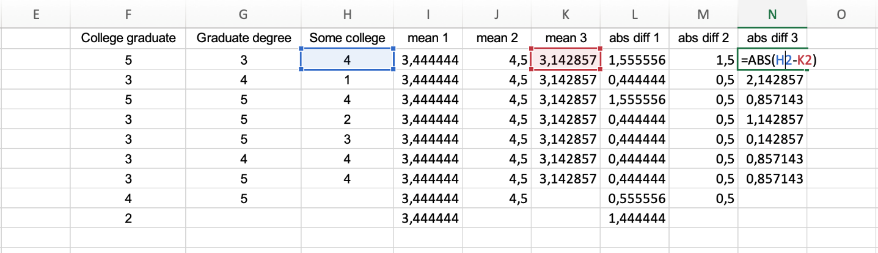

* Go to Data 🡪 Data Analysis 🡪 Choose ANOVA Single Factor. For **Input Range**, choose the cells where the absolute residuals are located. For **Output Range**, choose a cell where you would like the results of the one-way ANOVA to appear. Then click **OK**.

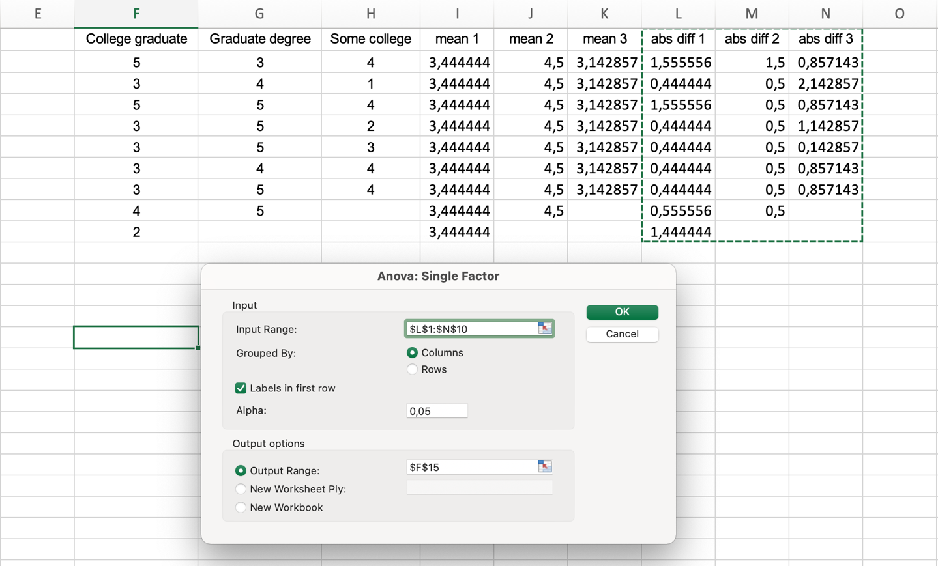

* View the result and conclude

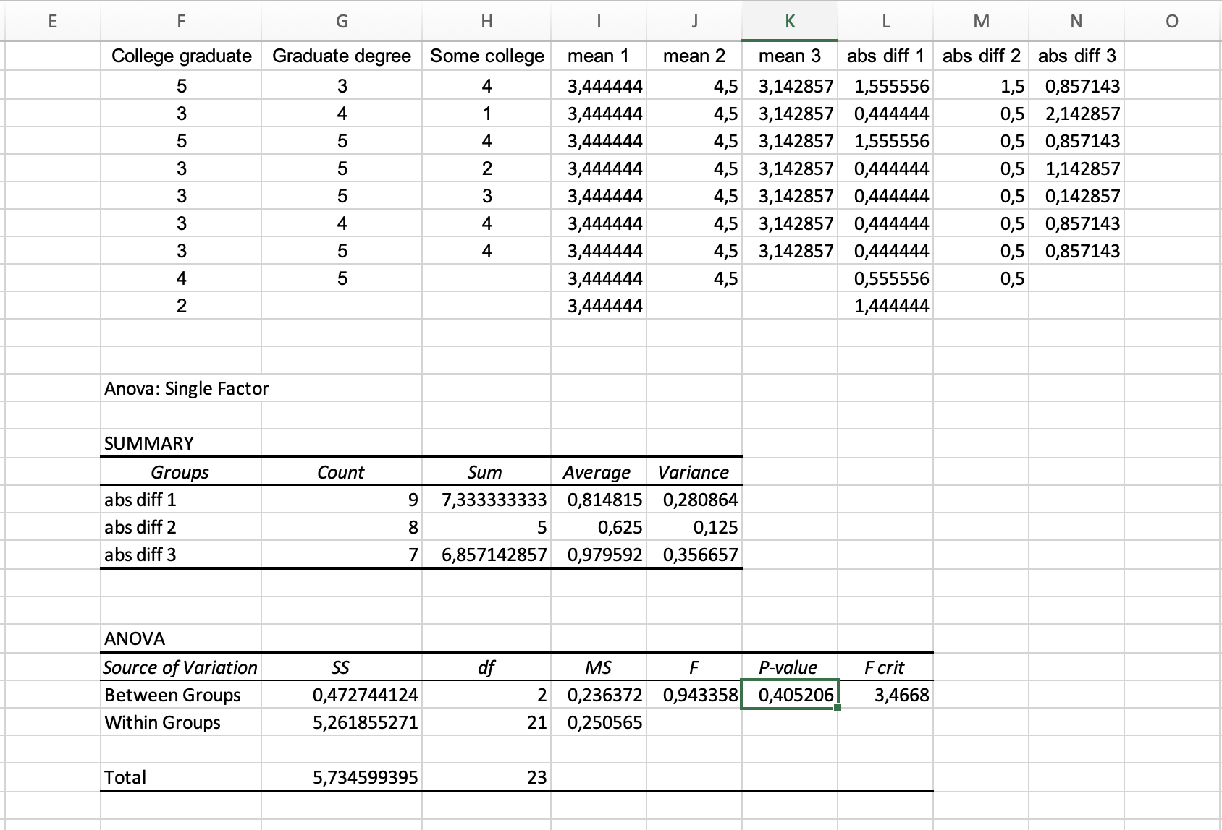

We can see that p-value is 0.405206 (>0.05). In Levene’s test, that means we can accept H0 (all the variance are equal) 🡪 Move to ANOVA test

**Step 2:** Do ANOVA test

* Go to Data 🡪 Data Analysis 🡪 Choose ANOVA Single Factor. For **Input Range**, choose the cells like the following image. For **Output Range**, choose a cell where you would like the results of the one-way ANOVA to appear. Then click **OK**.

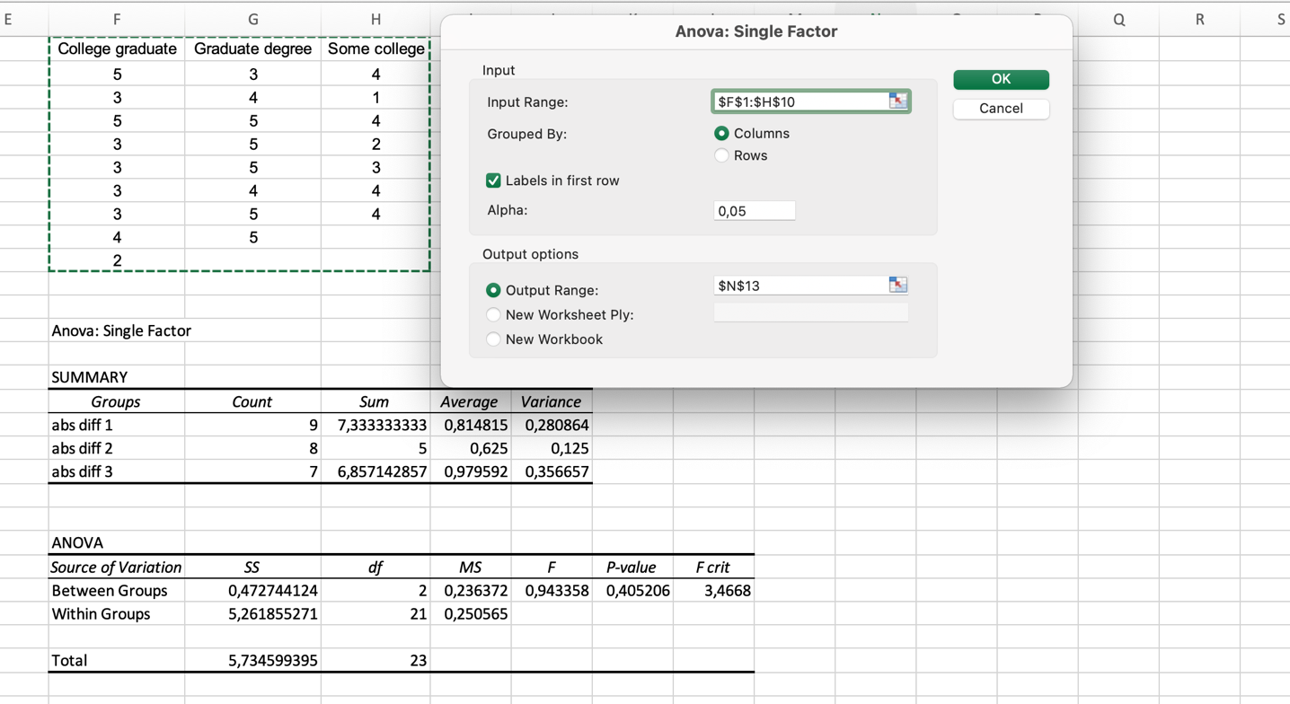

* View the result and conclude

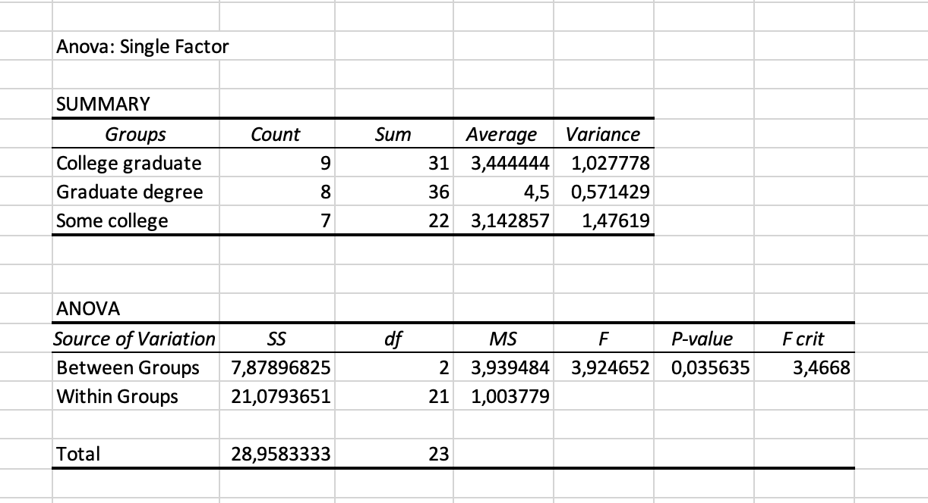

We can see that p-value is 0.035635 (<0.05). In ANOVA test, that means we reject H0, accept H1 (at least one education level is different from the others) 🡪 Move to Tukey test to determine exactly which group means are different.

**Step 3:** Do Tukey’s test

We define Q critical value like example in Exercise 2A (using the Studentized Range Q Table). If mean difference greater than Q 🡪 Significant.

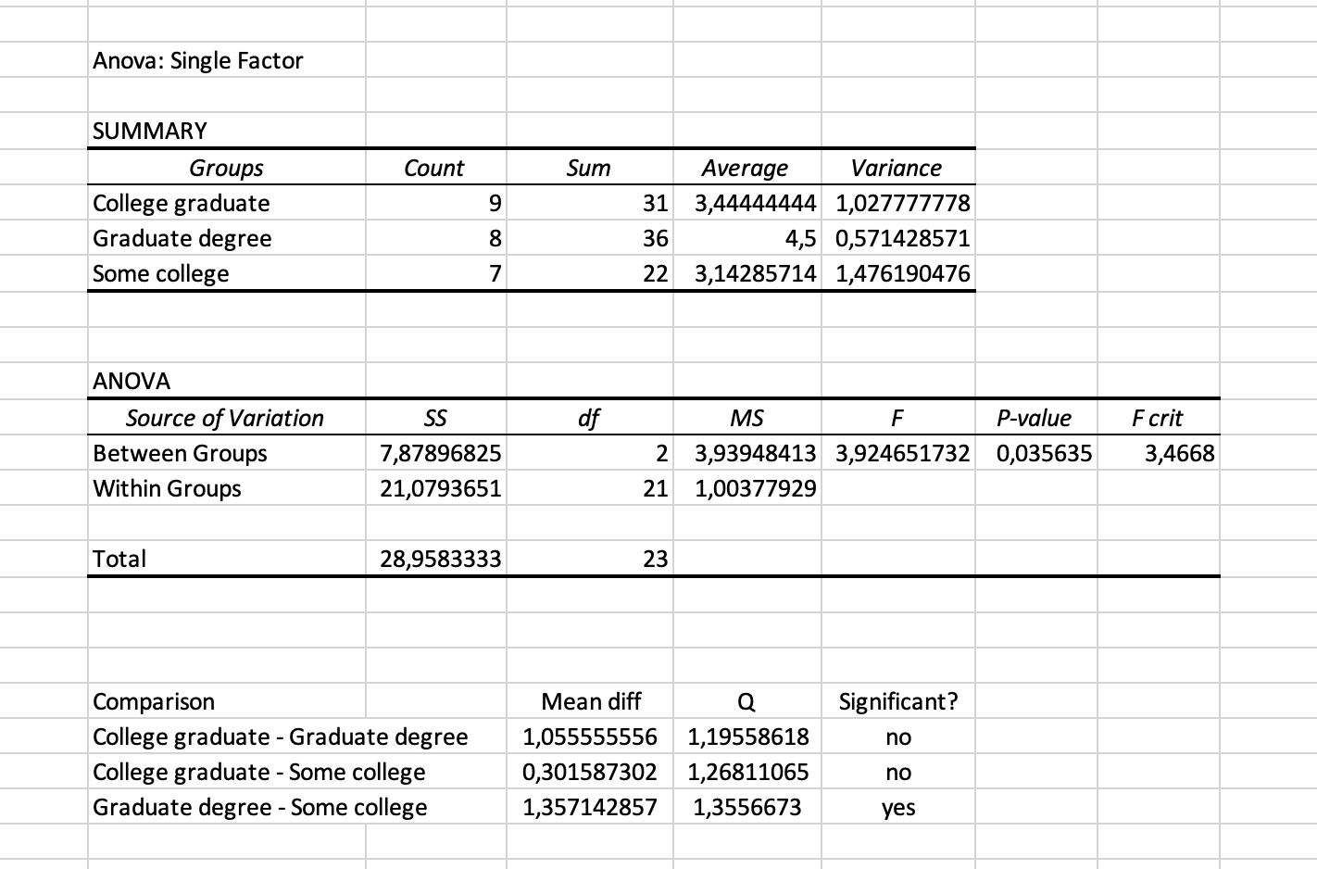

**Conclusion:**

* The difference in means between college graduate and graduate degree is *not* statistically significant.
* The difference in means between college graduate and some colleges is *not*statistically significant.
* The difference in means between some colleges and graduate degree is statistically significant.

1. EXERCISE 2C

**Problem statement:** A survey of favorite energy drink brands was conducted with 100 people. Respondents were classified by gender (male or female). The Chi Square test helps us determine whether brand choice and gender are dependent.

Hypothesis for Chi square test:

*H0: The brand choice and the gender are independent.*

*H1: The brand choice and the gender are dependent.*

* 1. R

**Step 1:**

* Convert **Energy**.**xlsx** file to **Energy**.**csv**. Select *CSV format like the picture below



**Step2:**

* Import file *csv in step 1 into RStudio Application

e_lab <-read.csv('Energy.csv', header = TRUE)



* Attach this file

attach(e_lab)



**Step 3:** We have to install and use library MASS

install.packages("MASS")



* In tab Packages, select **Install**



* Enter the library name, then click **Install**

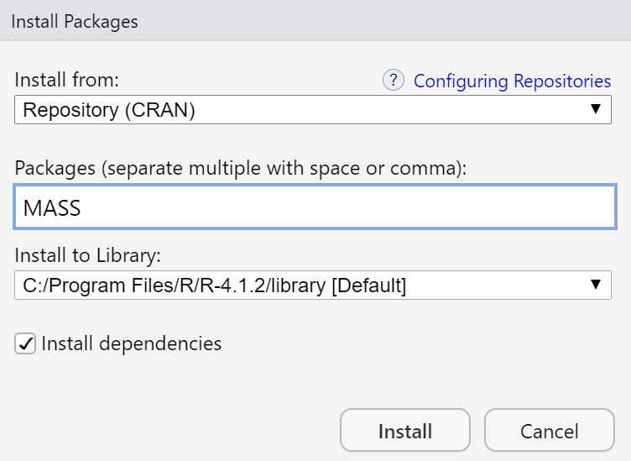

* After the installation is complete, we use the **require()** statement to use the library

require(MASS)



**Step 4:**

* Group Statistics

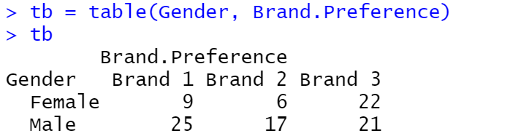

* Chi-squared Test

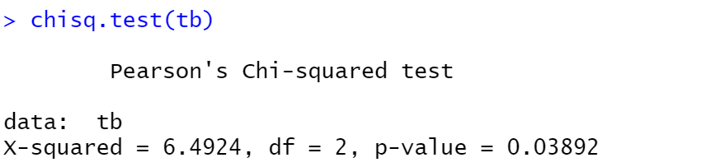

p-value = 0.03 < 0.05 🡪 Reject H0, two categorical variables are dependent.

* 1. Python

**Step 1:** Open Jupyter notebook

* Go to the folder containing the file **Energy.csv** and open **cmd**



* Enter the command “jupyter notebook”

jupyter notebook

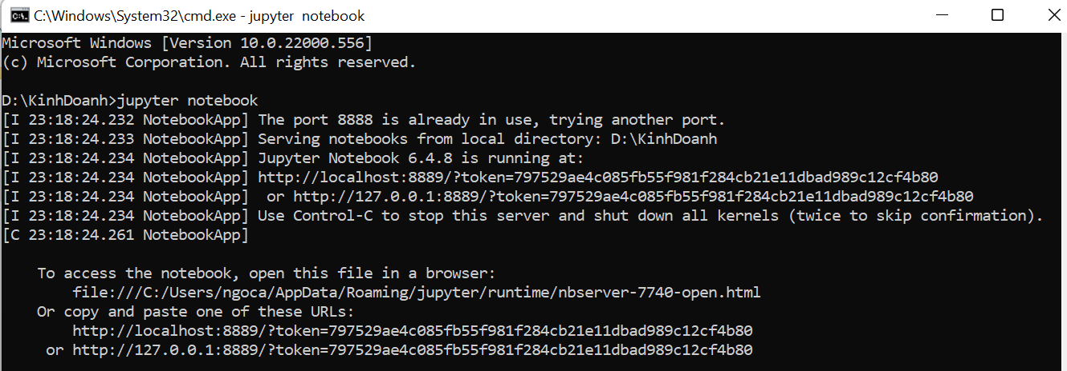

* Access the output link in the cmd



**Step 2:** Create new Python file

* Select the button **New** and click **Python 3** to create a new file

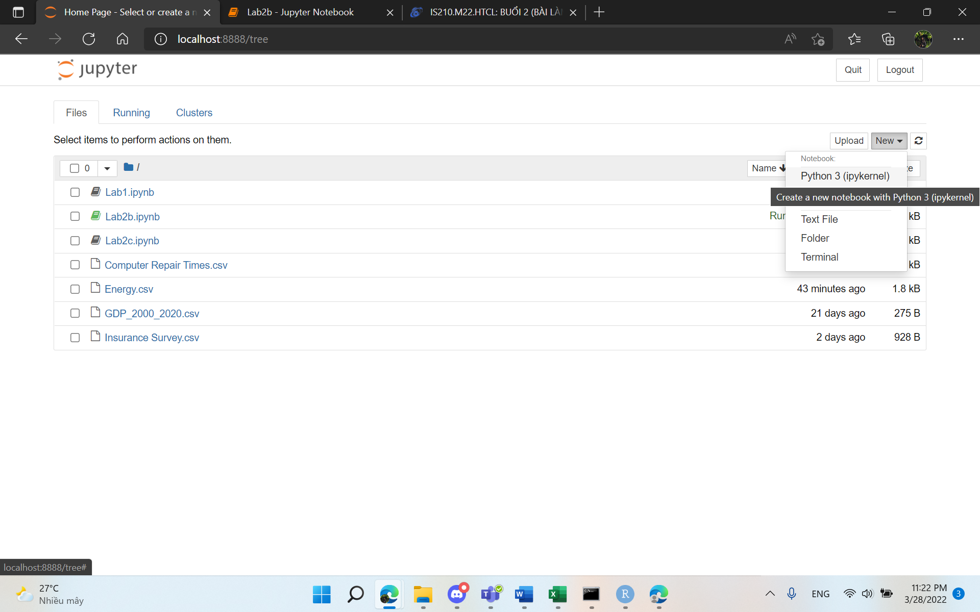

**Step 3:** Import library

import pandas as pd

**Step 4:** Import **Energy.csv** into the Jupyter

pt = pd.read_csv("Energy.csv")



**Step 5:** Chi-quare Test

chisqt=pd.crosstab(pt.Gender, pt['Brand Preference'])

print(chisqt)

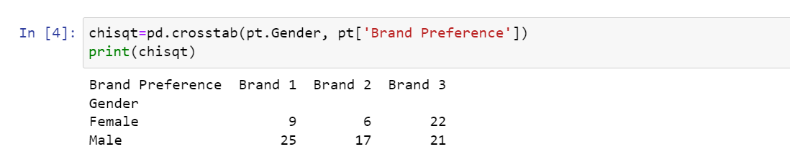

**Step 6:** Import library

import scipy.stats as stats



**Step 7:** p – value

c, p, dof, expected = stats.chi2_contingency(chisqt)

print(p)



p-value < 0.05 => Reject H0, two categorical variables are dependent.

* 1. MS EXCEL

Step 1: Calculate expected frequency

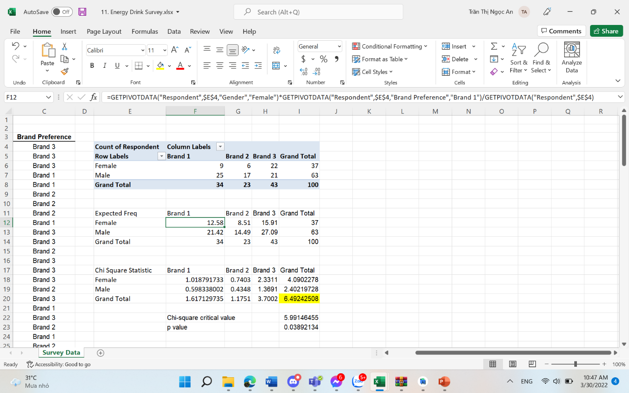

Step 2: Calculate Chi square statistic

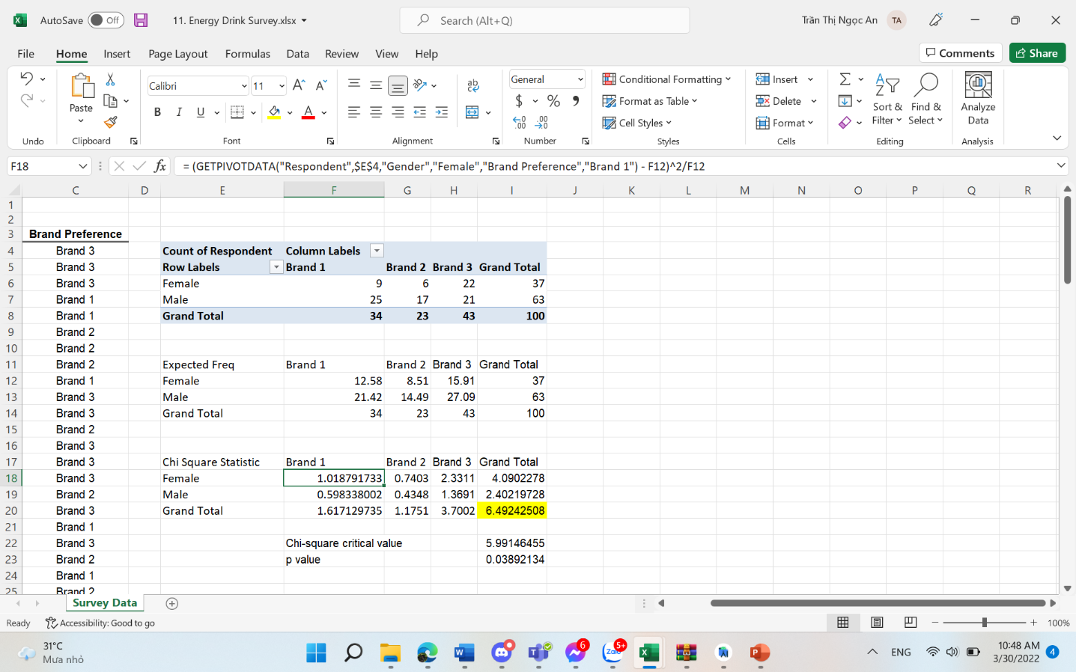

Step 3: Calculate Chi square critical value

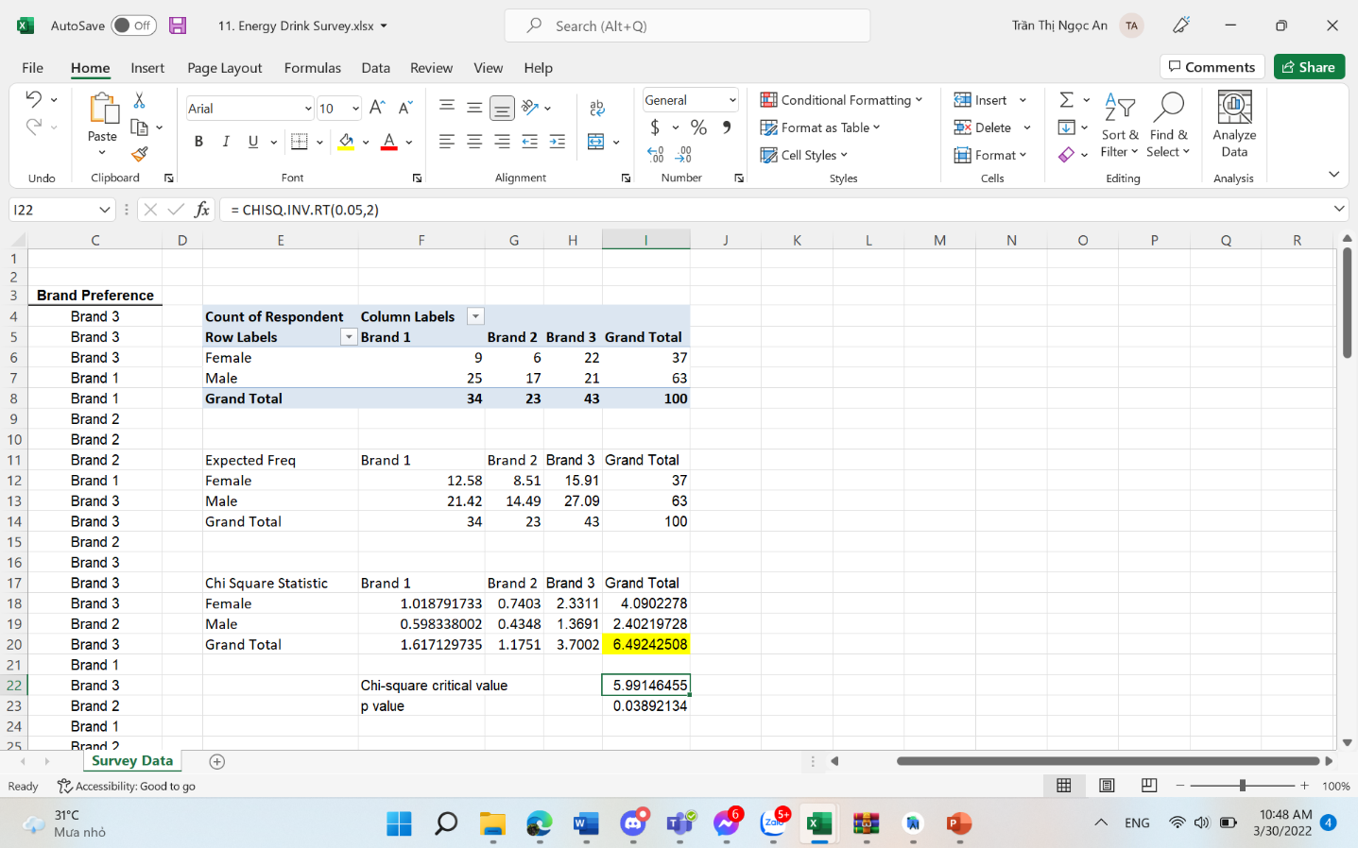

**Step 4:** Calculate p-value:

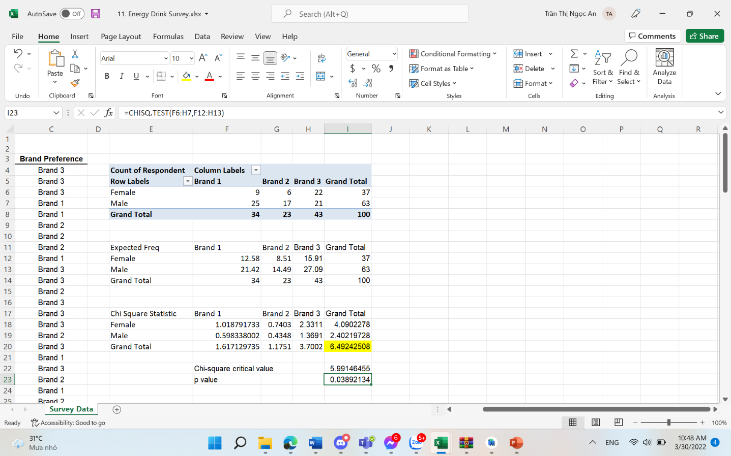

**Step 5:** View the result and conclude

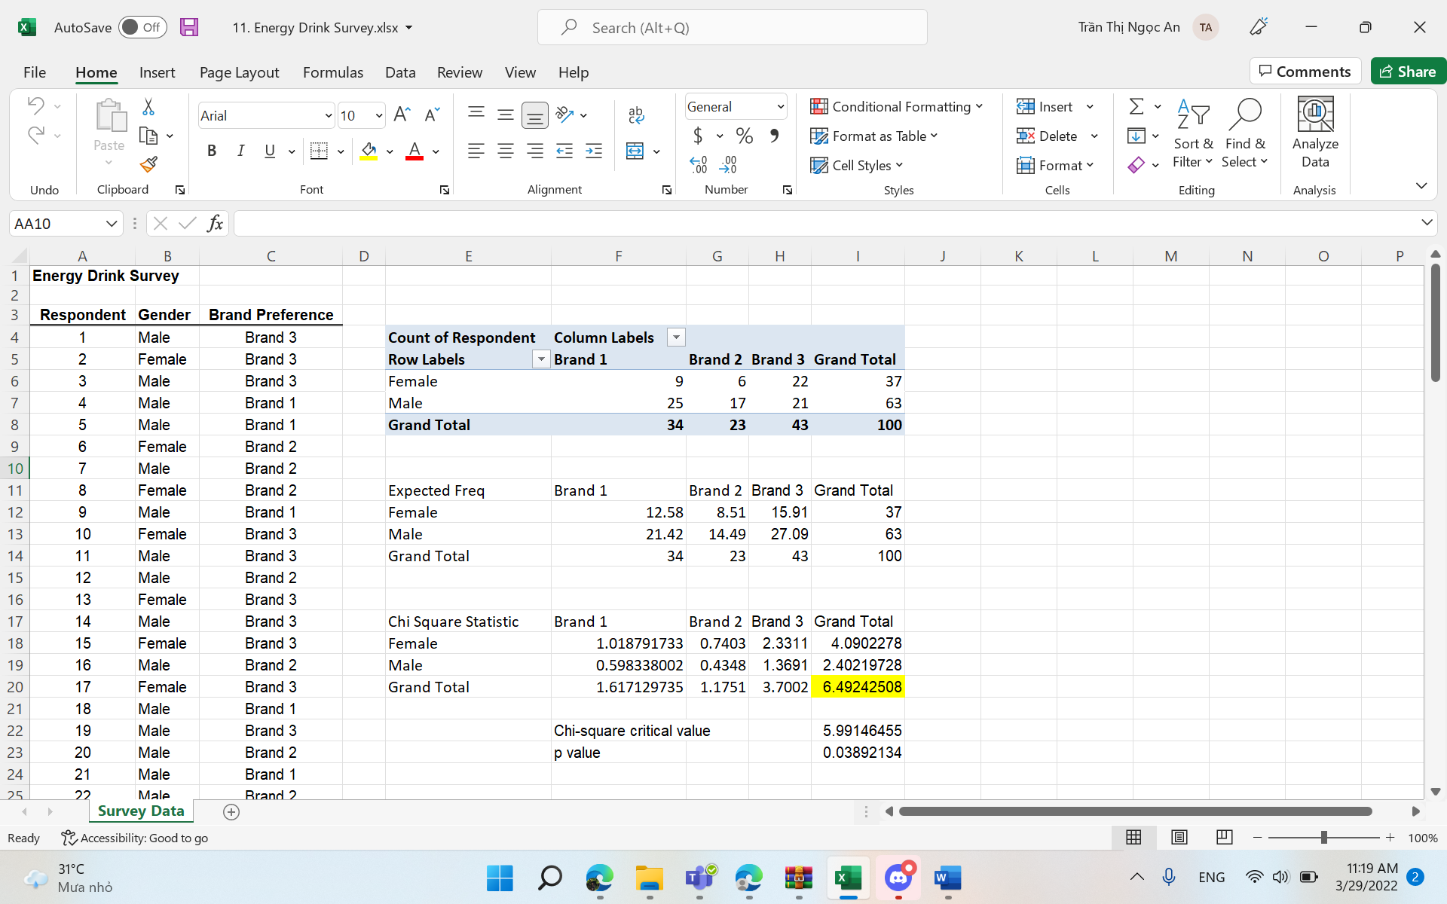

Comment:

* Chi-square Critical value < Chi-square Statistic (5.99 < 6.49) => Reject H0, two categorical variables are dependent.
* Or (p value): p value = 0.03 < 0.05 => Reject H0, two categorical variables are dependent.

**Conclusion:** The brand choice and the gender are dependent

1. EXERCISE 2D

**Problem statement:** This is the result of VietNam national highschool exam collected from 1000 pupils. These pupils scores are collected from three subjects: Math, Chemistry and Physics. The analysis aims to find out whether the mean score of each subject different or not from others.

Hypothesis for ANOVA test:

*H0: The mean score of each subject is not diffent from others (μ1 = μ2 = μ3)*

*H1: at least one subject has mean score different from the others*

* 1. R

**Step 1:**

* Import file *csv in step 1 into RStudio Application

vn_lab <-read.csv(' VIETNAM NATIONAL HIGHSCHOOL EXAM SCORE 2018.csv', header = TRUE)



* Attach this file

attach(vn_lab)



**Step 2:** We have to install and use library dplyr and DataCombine

install.packages("dplyr")



* In tab Packages, select **Install**



* Enter the library name, then click **Install**

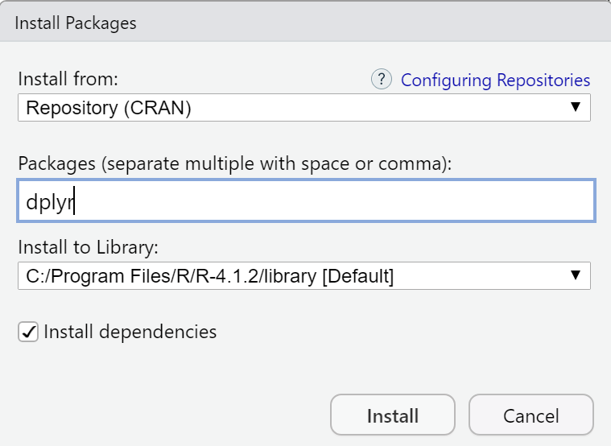

install.packages("DataCombine")



* In tab Packages, select **Install**



* Enter the library name, then click **Install**

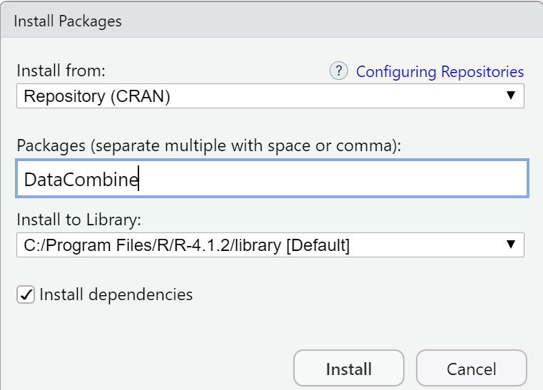

* After the installation is complete, we use the **require()** statement to use the library

require(dplyr)









**Step 3: Filter**

data <- select(vn_lab, one_of("Math","Physics","Chemistry"))



**Step 4: Change direction**

newsData <- stack(data)



**Step 5: Delete null data**

newData2<-DropNA(newsData,Var = "values")



**Step 6: Filter 1000 lines**

dataFinal<-sample_n(newsData2, 1000)



**Step 7: Export CSV file**

write.csv(dataFinal,"D:/KinhDoanh/Point.csv", row.names = TRUE)



**Step 8: ANOVA Test**

* Import file *csv in step 1 into RStudio Application

p_lab <-read.csv('Point.csv', header = TRUE)



* Attach this file

attach(p_lab)



**Step 9:** Then, we have to install and use library **car.**

install.packages("car")



* In tab Packages, select **Install**



* Enter the library name, then click **Install**



* After the installation is complete, we use the **require()** statement to use the library

require(car)





**Step 10:** Calculate levene

* After using the library successfully, we start calculate the Levene test throung the command

leveneTest(values ,ind,center="mean")

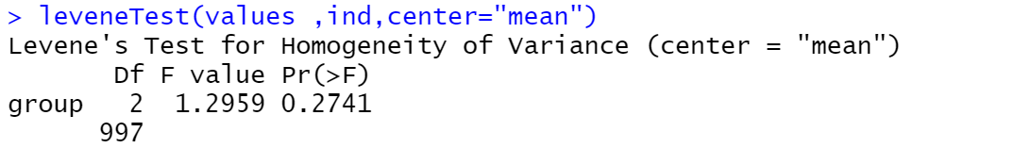

Since Pr (>F) > 0.05 (0.2741 > 0.05) 🡪 Reject H1

* All variances are equal and we can test Anova
* Look up: use function **qf** to calculate

qf(p=0.95,2,997)

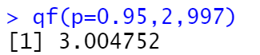

F value < F-Critical (1.2959 < 3.004), Reject H1, all variances are equal and we can test Anova

aov(values ~ind, data = p_lab)

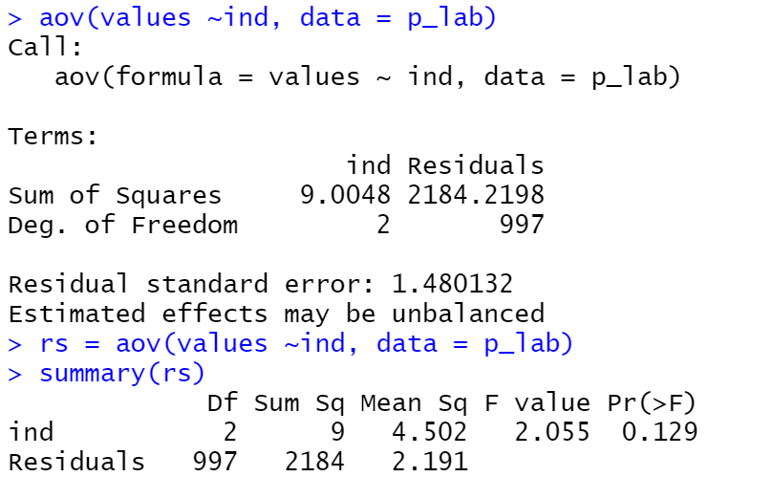

Using α = 0.05 , Pr(>F), p value = 0.129 > 0.05 🡪 Reject H1. Obviously, we don’t need to do Tukey test because there is nothing different between each group. But we still do Tukey to confirm that again.

**Step 4: Calculate to Turkey**

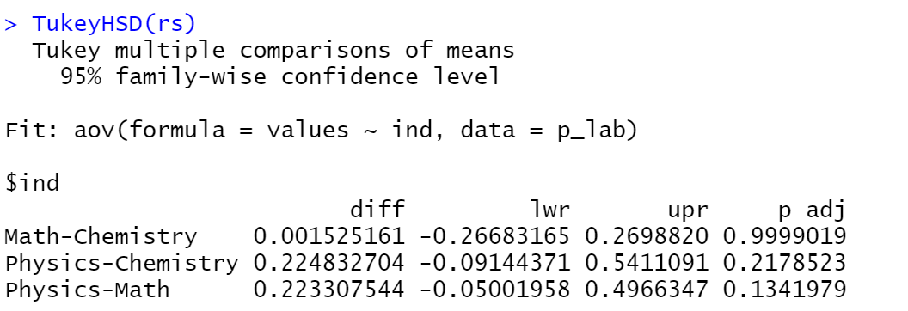

With α = 0.05, Similar group (P-adj > 0.05) => Reject H1

* 1. PYTHON

**Step 1:** Open Jupyter notebook

* Go to the folder containing the file **Point.csv** and open **cmd**



* Enter the command “jupyter notebook”

jupyter notebook

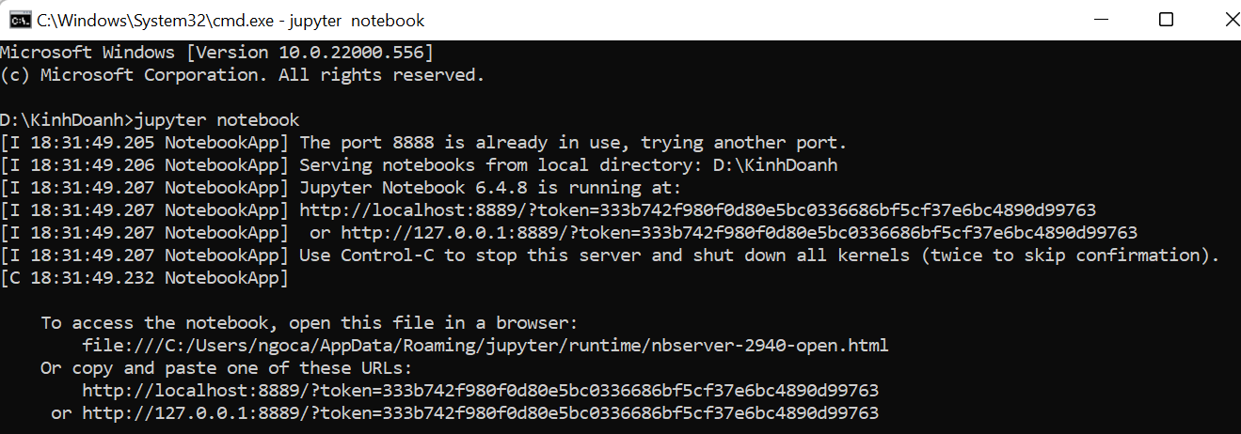

* Access the output link in the cmd



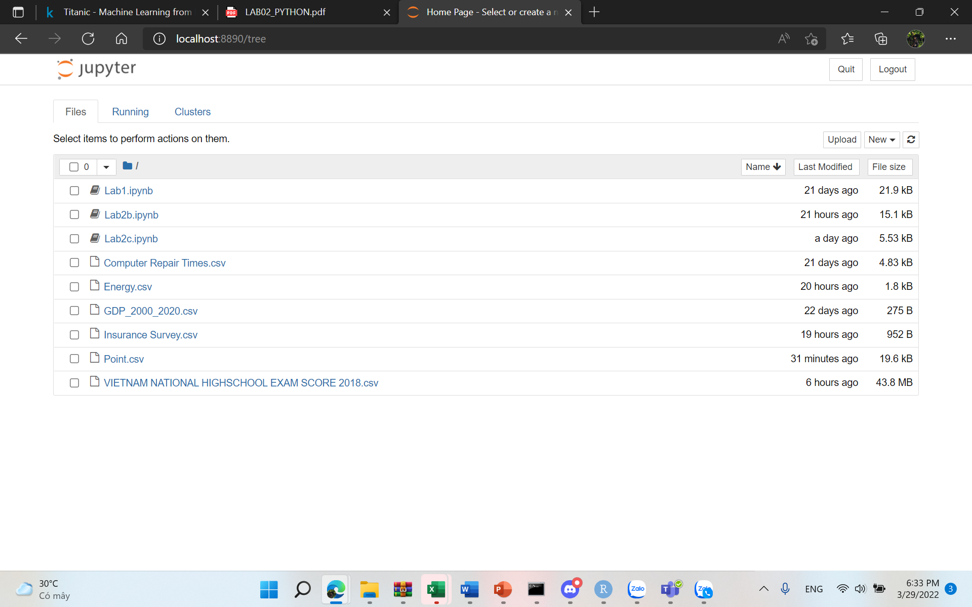

**Step 2:** Create new Python file

* Select the button **New** and click **Python 3** to create a new file

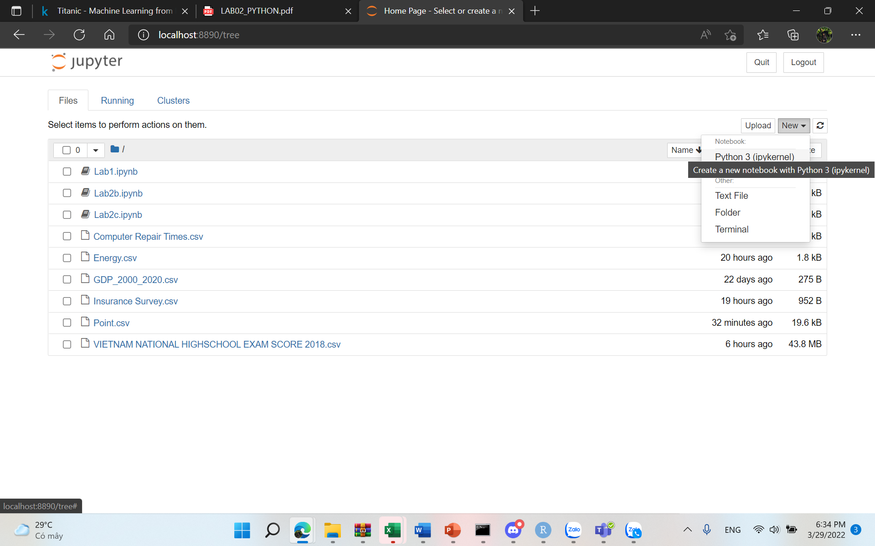

**Step 3:** Import library

import pandas as pd

**Step 4:** Import **Point.csv** into the Jupyter

p_lab = pd.read_csv("Point.csv")

**Step 5:** Group data into group function

df2 = p_lab.groupby('ind')['values'].apply(list)

print (df2)

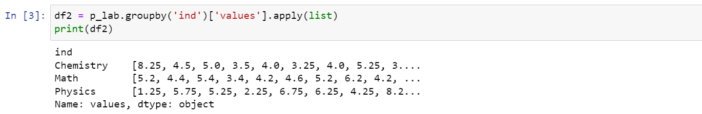

**Step 6:** Import library

from scipy.stats import levene



**Step 7:** Use Python’s Levene function to check determined Levene

stat,p= levene(*df2,center = 'mean')

print(stat,p)

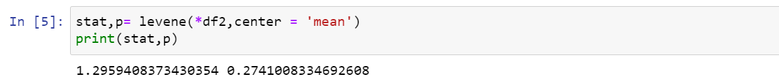

p-value > 0.05 (0.27 > 0.05) 🡪 Reject H1, all variances are equal and we can test Anova

**Step 8:** Import library

import scipy.stats as stats

fvalue, pvalue = stats.f_oneway(*df2)

print(fvalue,pvalue)

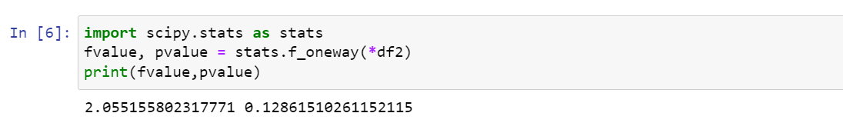

p-value > 0.05 (0.12 > 0.05 ) 🡪 Reject H1. Obviously, we don’t need to do Tukey test because there is nothing different between each group. But we still do Tukey to confirm that again.

**Step 9:** To calculate the Turkey

from statsmodels.stats.multicomp import pairwise_tukeyhsd

tukey = pairwise_tukeyhsd(endog=df['values'],groups=df.ind, alpha=0.05)

print(tukey)

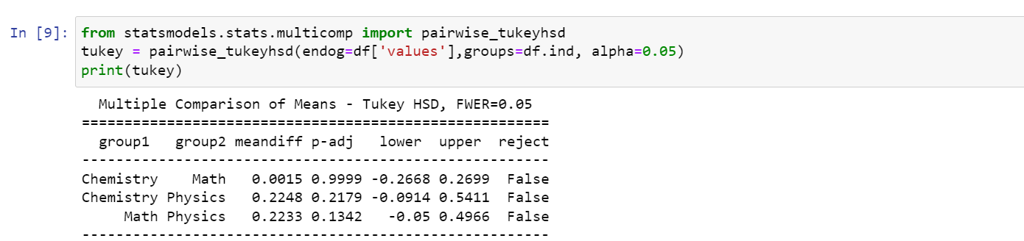

With α = 0.05, Similar Groups (P-adj > 0.05) 🡪 Reject H1

* 1. Excel

**Step 1:** Do Levene’s test

* Calculate the mean of each group

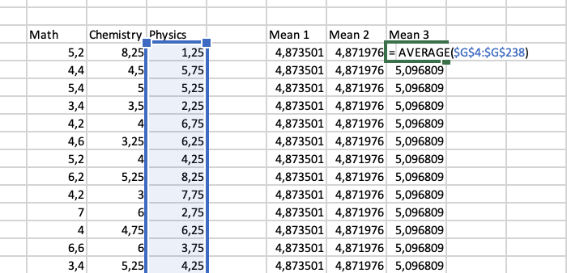

* Calculate the absolute residual

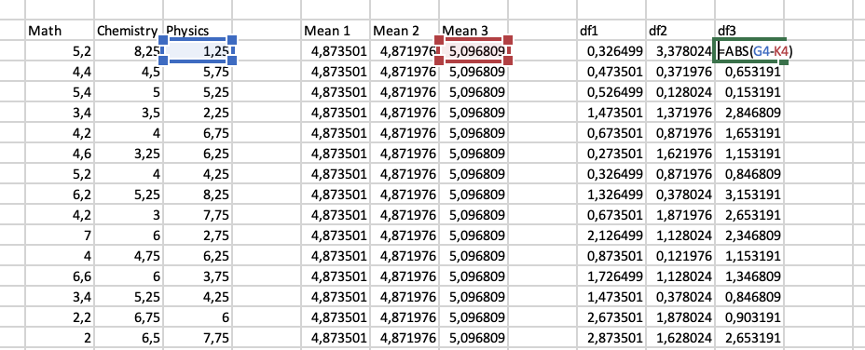

* Go to Data 🡪 Data Analysis 🡪 Choose ANOVA Single Factor. For **Input Range**, choose the cells where the absolute residuals are located. For **Output Range**, choose a cell where you would like the results of the one-way ANOVA to appear. Then click **OK**.

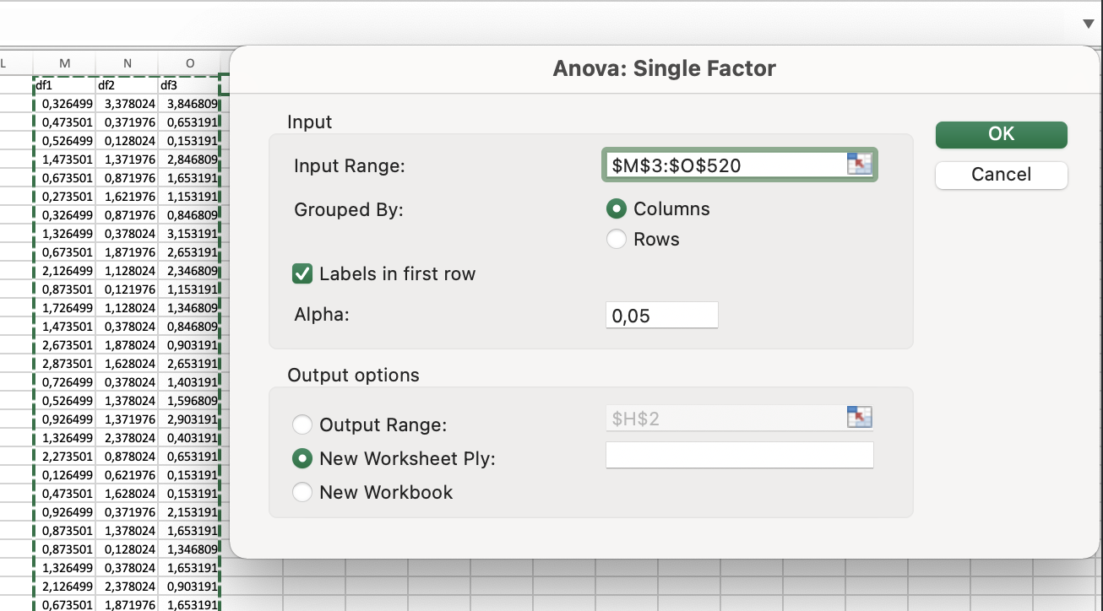

* View the result and conclude

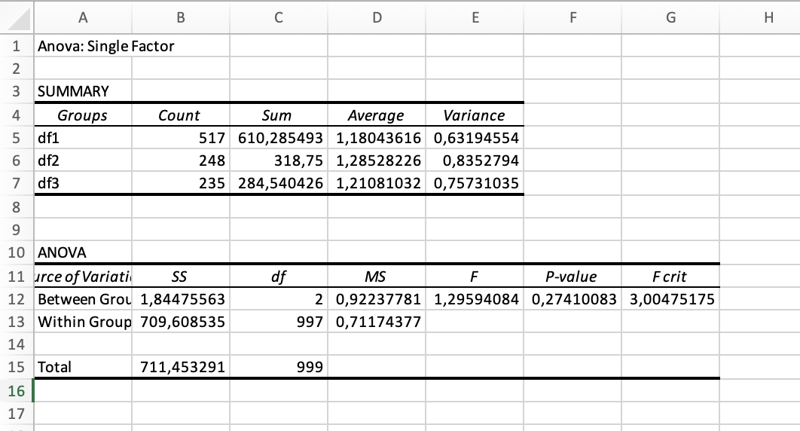

We can see that p-value is 0.26815094 (>0.05). In Levene’s test, that means we can accept H0 (all the variance are equal) 🡪 Move to ANOVA test

**Step 2:** Do ANOVA test

* Go to Data 🡪 Data Analysis 🡪 Choose ANOVA Single Factor. For **Input Range**, choose the cells like the following image. For **Output Range**, choose a cell where you would like the results of the one-way ANOVA to appear. Then click **OK**.

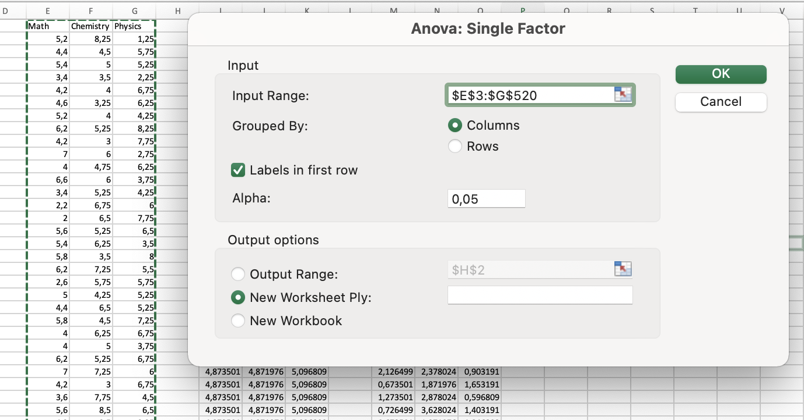

* View the result and conclude

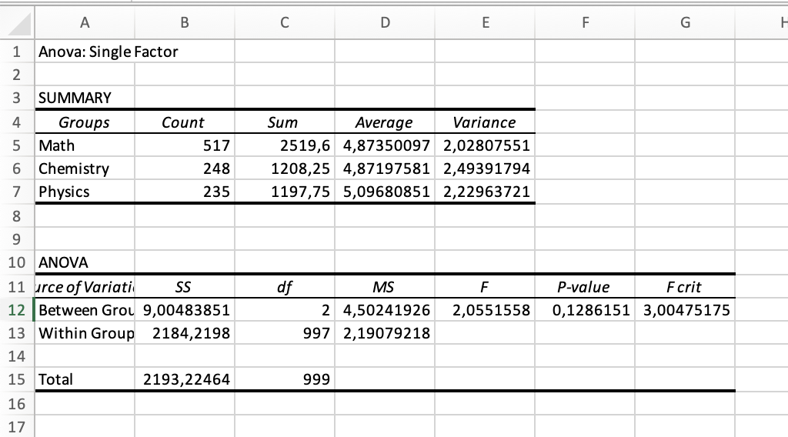

We can see that p-value is 0.1286151 (>0.05). In ANOVA test, that means we acceptt H0, reject H1. Obviously, we don’t need to do Tukey test because there is nothing different between each group. But we still do Tukey to confirm that again.

**Step 3:** Do Tukey’s test

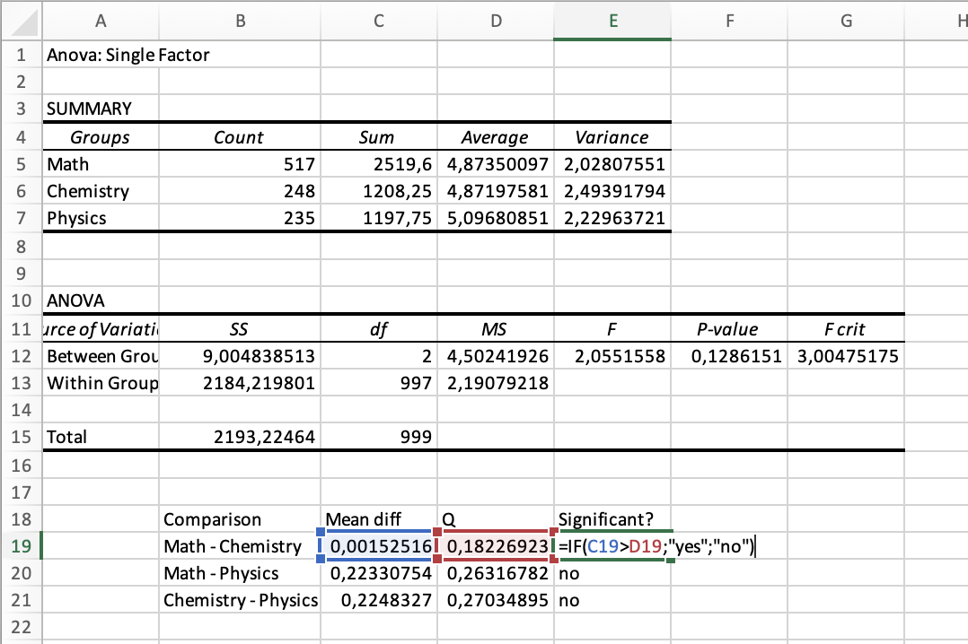

**Conclusion:**

* The difference in means between math and chemisstry is *not* statistically significant.
* The difference in means between math and physics is *not*statistically significant.
* The difference in means between physics and chemistryis *not* statistically significant.

1. EXERCISE 2E

**Problem statement:** This dataset is the information of 418 passenger on Titanic that fateful day. Passengers were classified by gender (male or female). The Chi Square test helps us determine whether gender affect or not to the survival of passenger.

Hypothesis for Chi square test:

*H0: Passenger survival and gender are independent.*

*H1: Passenger survival and gender are dependent, all and only female passengers survive*

* 1. R

**Step 1:**

* Convert **Titanic**.**xlsx** file to **Titanic**.**csv**. Select *CSV format like the picture below



**Step2:**

* Import file *csv in step 1 into RStudio Application

gs_lab <-read.csv('Titanic.csv', header = TRUE)



* Attach this file

attach(gs_lab)



**Step 3:** We have to install and use library MASS

install.packages("MASS")



* In tab Packages, select **Install**



* Enter the library name, then click **Install**



* After the installation is complete, we use the **require()** statement to use the library

require(MASS)



**Step 4:**

* Group Statistics

tb = table(Sex, Survived)

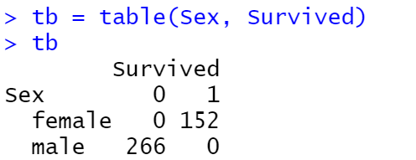

* Chi-squared Test

chisq.test(tb)

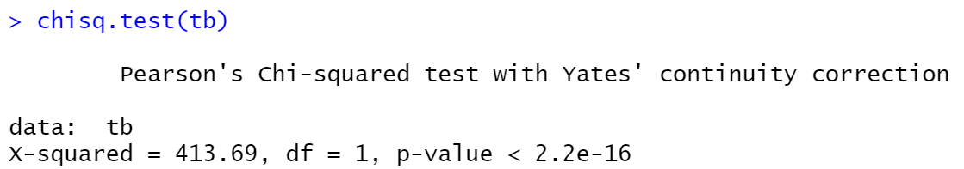

p-value = 2.2e-16 < 0.05 🡪 Reject H0, two categorical variables are dependent.

* 1. Python

**Step 1:** Open Jupyter notebook

* Go to the folder containing the file **Titanic.csv** and open **cmd**



* Enter the command “jupyter notebook”

jupyter notebook

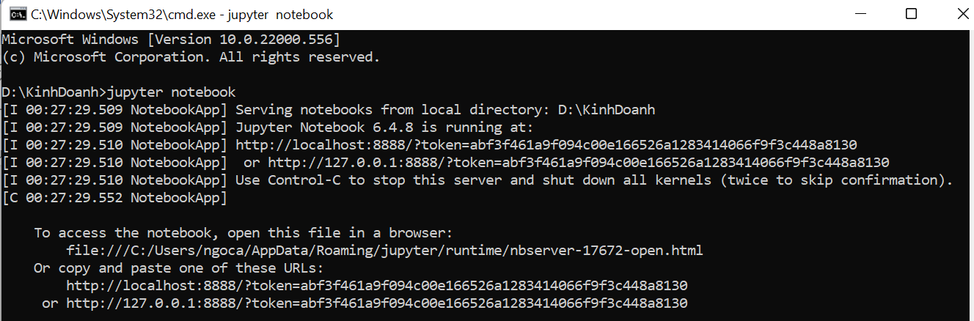

* Access the output link in the cmd



**Step 2:** Create new Python file

* Select the button **New** and click **Python 3** to create a new file

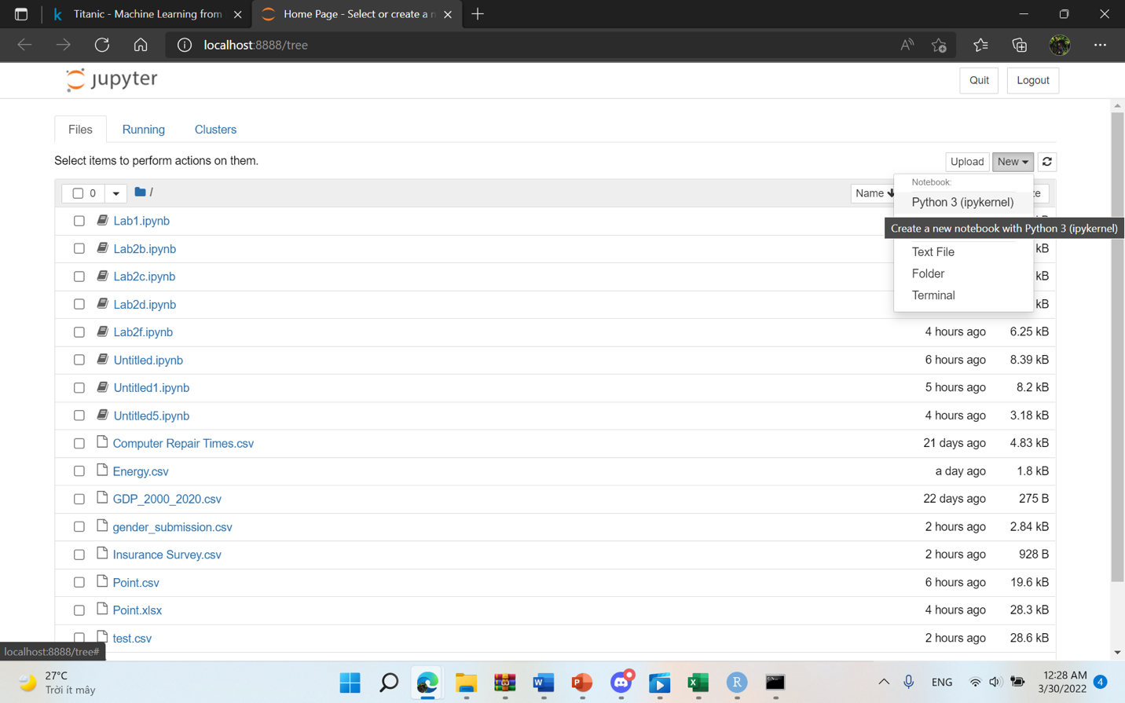

**Step 3:** Import library

import pandas as pd



**Step 4:** Import **Titanic.csv** into the Jupyter

pt = pd.read_csv("Titanic.csv")



**Step 5:** Chi-quare Test

chisqt=pd.crosstab(pt.Sex, pt['Survived'])

print(chisqt)

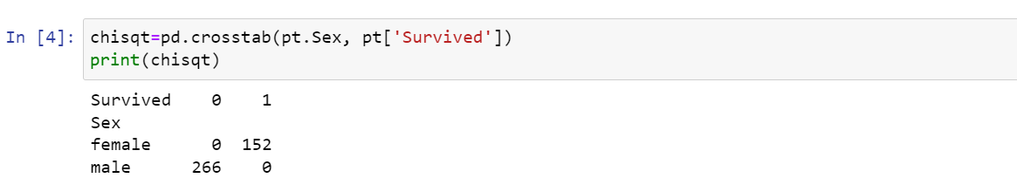

**Step 6:** Import library

import scipy.stats as stats



**Step 7:** p – value

c, p, dof, expected = stats.chi2_contingency(chisqt)

print(p)

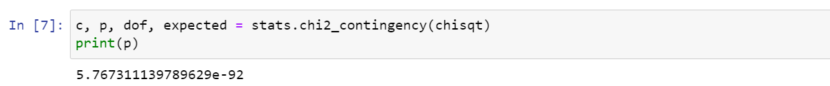

p-value < 0.05 🡪 Reject H0, two categorical variables are dependent.

* 1. MS EXCEL

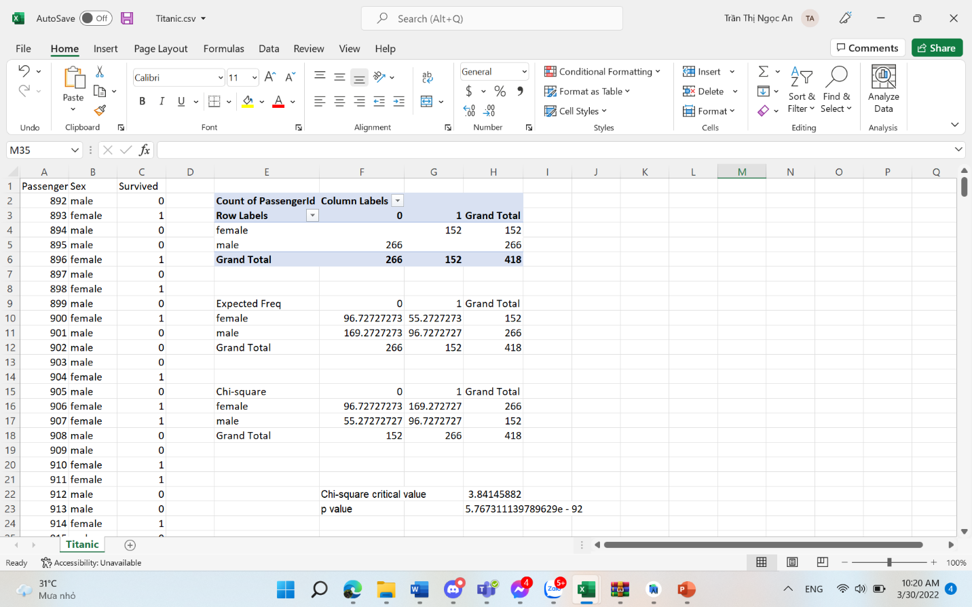

Comment:

* Chi-square Critical value < Chi-square Statistic (3,8414 < 418) 🡪 Reject H0, two categorical variables are dependent.
* Or (p value): p value = 5,767e - 92 < 0.05 🡪 Reject H0, two categorical variables are dependent.

**CONCLUSION:** Passenger survival and gender are dependent, all and only female passengers survive

1. EXERCISE 2F

**Problem statement:** This is a statistic posted publicly by the General Statistics Office of Vietnam (Link: [https://www.gso.gov.vn/px-web-2/?pxid=V1015&theme=Giáo%20dục](https://www.gso.gov.vn/px-web-2/?pxid=V1015&theme=Gi%C3%A1o%20d%E1%BB%A5c)). Dataset includes the high school graduation rate in Vietnam (2016-2017), which is collected from 63 provinces and cities, divided into 3 main regions: North, Central, and South. The analysis aims to find out whether the mean rate of each region different or not from others.

Hypothesis for ANOVA test:

*H0: The mean rate of each region is not diffent from others (μ1 = μ2 = μ3)*

*H1: at least one region has mean rate different from the others*

* 1. R

**Step 1:** Convert **tyletotnghiep.xlsx** file to **tyletotnghiep.csv**. Select *CSV format like the picture below



**Step2:**

* Import file *csv in step 1 into RStudio Application

rate_lab <-read.csv(' tyletotnghiep.csv', header = TRUE)



* Attach this file

attach(rate_lab)



**Step 3:** Then, we have to install and use library **car.**

install.packages("car")



* In tab Packages, select **Install**



* Enter the library name, then click **Install**



* After the installation is complete, we use the **require()** statement to use the library

require(car)





**Step 4:**

* After using the library successfully, we start calculate the Levene test throung the command

leveneTest(frequency,region,center="mean")

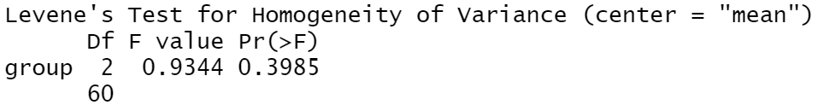

Since Pr (>F) > 0.05 (0.3985 > 0.05) 🡪 Reject H1

* All variances are equal and we can test Anova
* Look up: use function **qf** to calculate

qf(p=0.95,2,60)

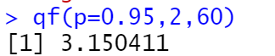

F value < F-Critical (0.9344 < 3.1504), Reject H1, all variances are equal and we can test Anova

aov(frequency ~region, data = rate_lab)

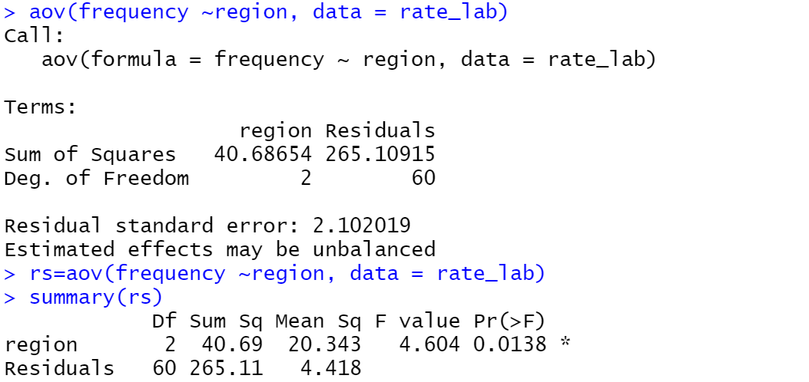

Using α = 0.05 ,Pr(>F), p value = 0.0356 < 0.05 🡪 Reject H0, at least one mean is different from the others

**Step 5: Calculate the Turkey**

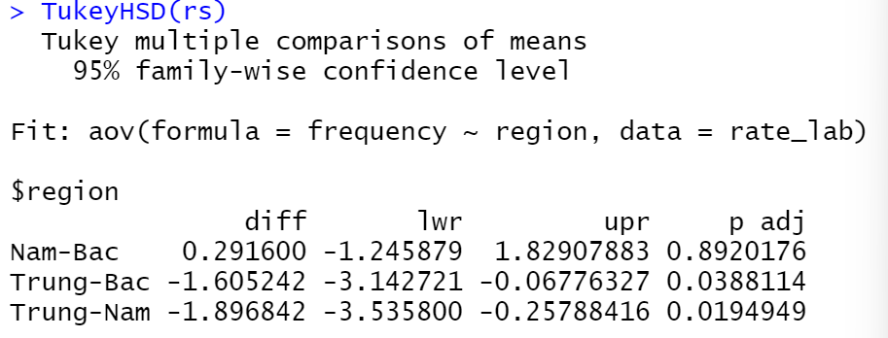

With α = 0.05, Nam-Bac different from the other two groups (P-adj = 0.8920 > 0.05) => Reject H0, at least one mean is different from the others.

* 1. PYTHON

**Step 1:** Open Jupyter notebook

* Go to the folder containing the file **tyletotnghiep.csv** and open **cmd**



* Enter the command “jupyter notebook”

jupyter notebook



* Access the output link in the cmd





**Step 2:** Create new Python file

* Select the button **New** and click **Python 3** to create a new file



**Step 3:** Import library

import pandas as pd



**Step 4:** Import **tyletotnghiep.csv** into the Jupyter

df = pd.read_csv("tyletotnghiep.csv")



**Step 5:** Group data into group function

df2 = df.groupby('region')['frequency '].apply(list)

print (df2)

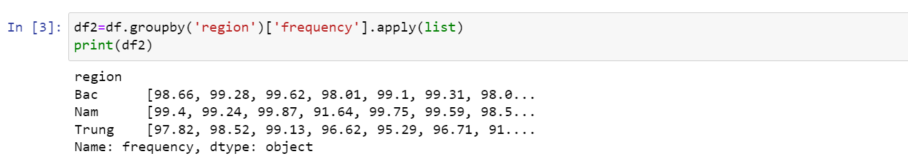

**Step 6:** Import library

from scipy.stats import levene



**Step 7:** Use Python’s Levene function to check determined Levene

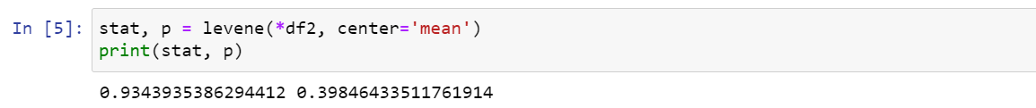

p-value > 0.05 (0.398 > 0.05) => Reject H1, all variances are equal and we can test Anova

**Step 8:** Import library

import scipy.stats as stats

fvalue, pvalue = stats.f_oneway(*df2)

print(fvalue,pvalue)

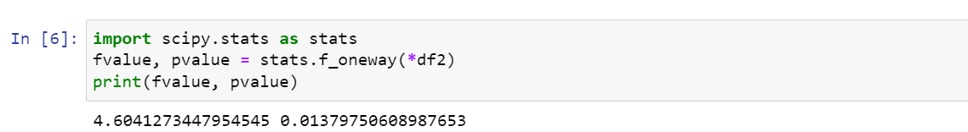

p-value < 0.05 (0.013 < 0.05 ) 🡪 Reject H0, at least one mean is different from the other, we can test Turkey

**Step 9:** To use the Turkey function, we start **install statsmodels**



**Step 10:**

from statsmodels.stats.multicomp import pairwise_tukeyhsd

tukey = pairwise_tukeyhsd(endog=df['frequency'],groups=df.region, alpha=0.05)

print(tukey)

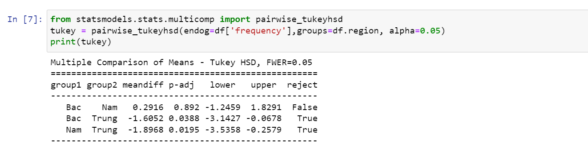

With α = 0.05, Bac Nam different from the other two groups (P-adj = 0.892 > 0.05) 🡪Reject H0, at least one mean is different from the others.

* 1. Excel

**Step 1:** Do Levene’s test

* Calculate the mean of each group

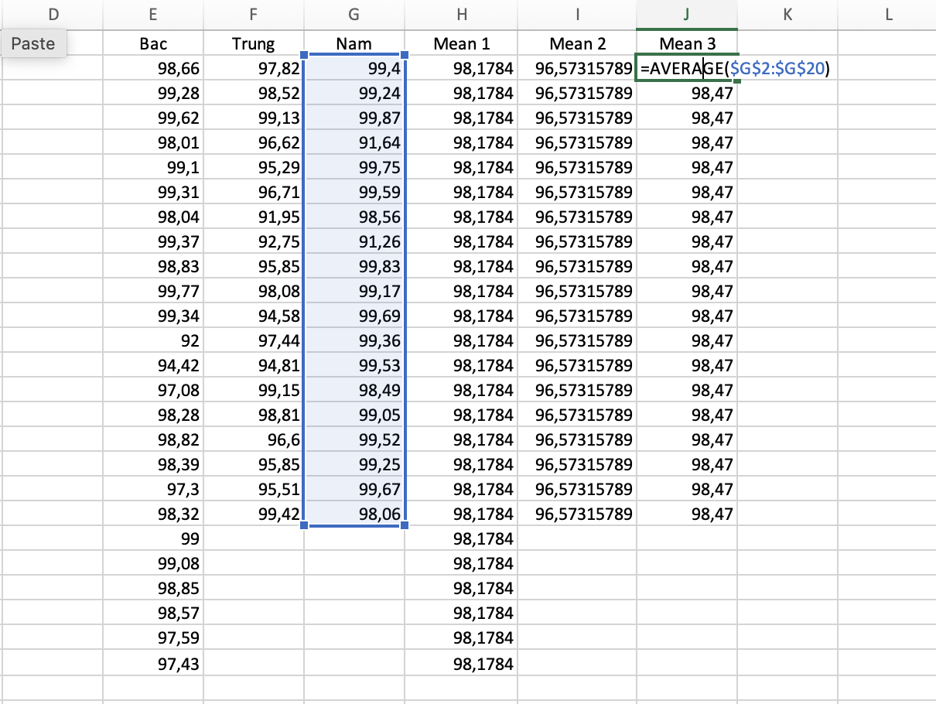

* Calculate the absolute residual

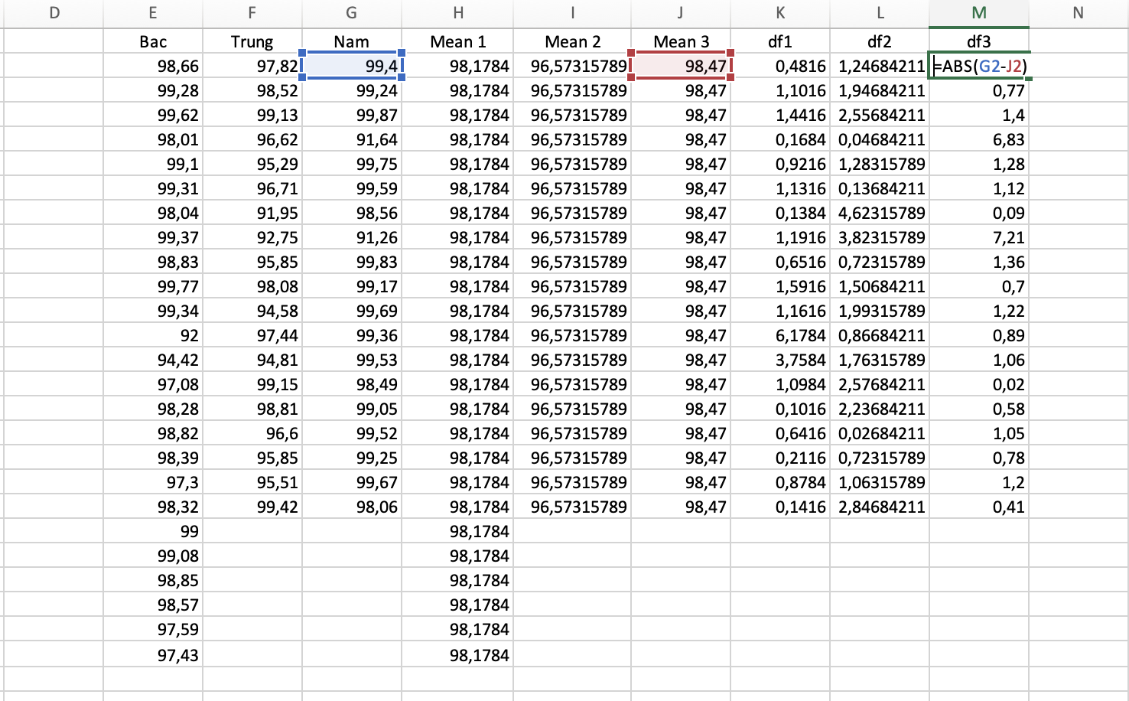

* Go to Data 🡪 Data Analysis 🡪 Choose ANOVA Single Factor. For **Input Range**, choose the cells where the absolute residuals are located. For **Output Range**, choose a cell where you would like the results of the one-way ANOVA to appear. Then click **OK**.

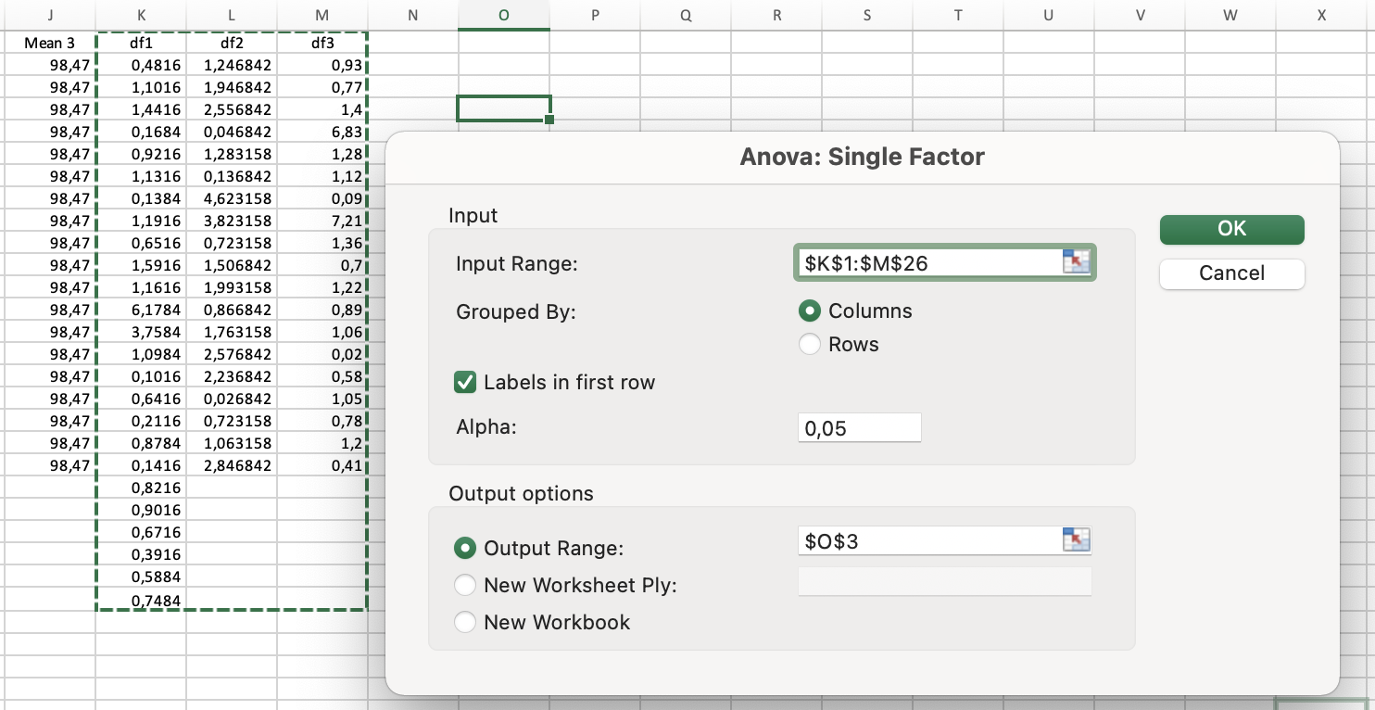

* View the result and conclude

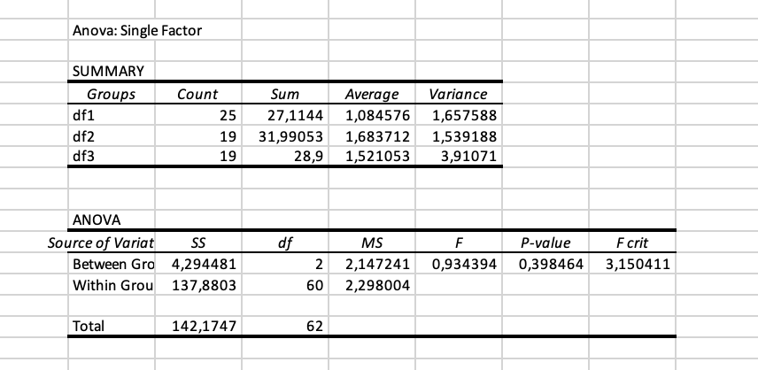

We can see that p-value is 0.398464 (>0.05). In Levene’s test, that means we can accept H0 (all the variance are equal) 🡪 Move to ANOVA test

**Step 2:** Do ANOVA test

* Go to Data 🡪 Data Analysis 🡪 Choose ANOVA Single Factor. For **Input Range**, choose the cells like the following image. For **Output Range**, choose a cell where you would like the results of the one-way ANOVA to appear. Then click **OK**.

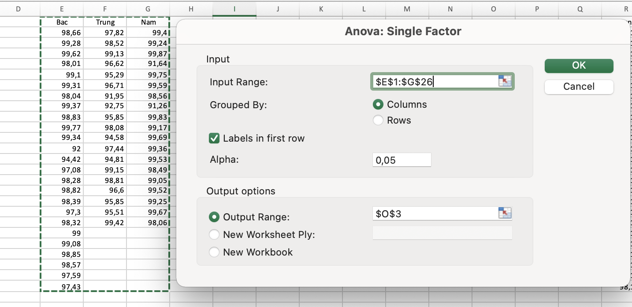

* View the result and conclude

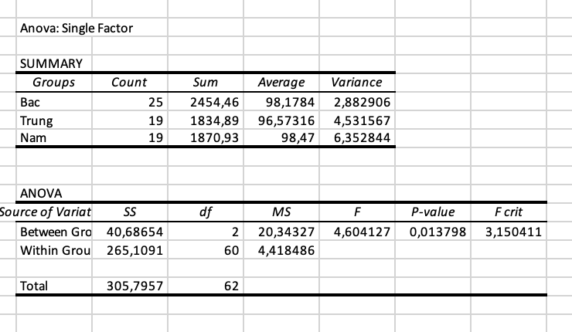

We can see that p-value is 0.013798 (<0.05). In ANOVA test, that means we reject H0, accept H1 (at least one education level is different from the others) 🡪 Move to Tukey test to determine exactly which group means are different.

**Step 3:** Do Tukey’s test

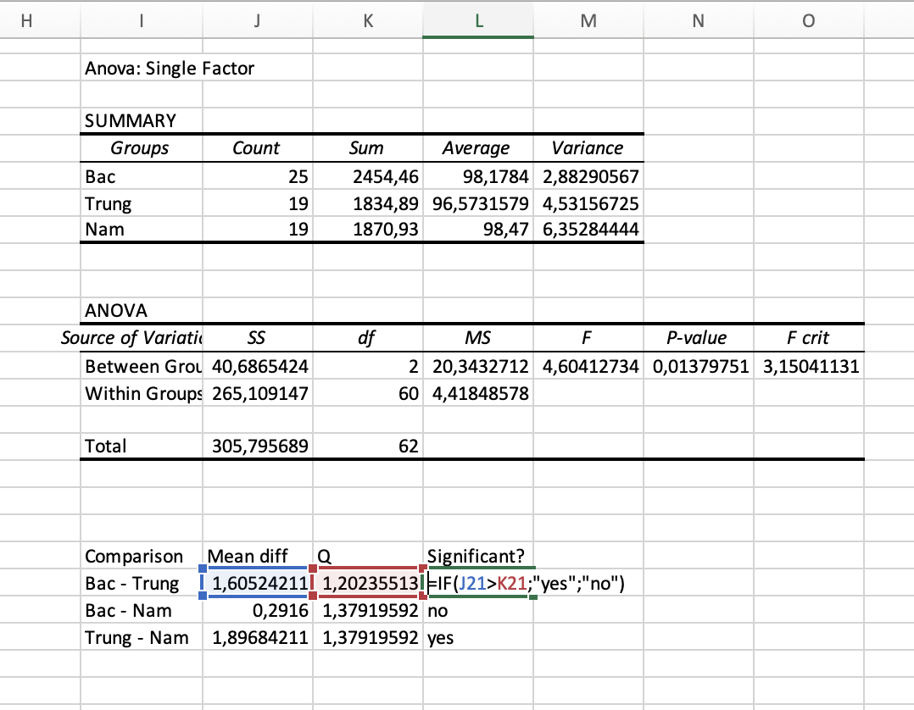

**Conclusion:**

Based on the results of the Tukey test, we can see that there is a difference between the graduation rates of the three regions in the country. As follows:

- The North and the South have no significant difference

- There is a significant difference between the North and the Central region

- The South and the Central region also have significant differences

=> This reflects that, provinces/cities with favorable socio-economic conditions, with a tradition of learning and teaching, have a high graduation rate (such as the North and the South).

In some provinces/cities with low socio-economic conditions, the graduation rate is still not high (like the central provinces).

Through this data, we see that the government needs to pay special attention to the central provinces more, need to improve their living standards more to improve the quality of education.

1. EXERCISE 2G

**Problem statement:** This dataset is the information of 3225 Covid-19 patients that uploaded on Kaggle (Link: <https://www.kaggle.com/datasets/shirmani/characteristics-corona-patients?select=Characteristics_Corona_patients+version+5+06122020.csv>). There was so many rows of data but our team have cleaned it and just pick patients from 3 country: French, Korea and VietNam. There are 2 status of them: cured and decease. The Chi Square test helps us determine whether country affect or not to the illness severity of Covid-19 patient.

Hypothesis for Chi square test:

*H0: Illness severity and country are independent.*

*H1: Illness severity and coutry are dependent.*

* 1. R

**Step 1:**

* Convert **Covidpatient.xlsx** file to **Covidpatient**.**csv**. Select *CSV format like the picture below



**Step2:**

* Import file *csv in step 1 into RStudio Application

covid_lab <-read.csv('Covidpatient.csv', header = TRUE)



* Attach this file

attach(covid_lab)



**Step 3:** We have to install and use library MASS

install.packages("MASS")



* In tab Packages, select **Install**



* Enter the library name, then click **Install**



* After the installation is complete, we use the **require()** statement to use the library

require(MASS)



**Step 4:**

* Group Statistics

tb = table(country, severity_illness)

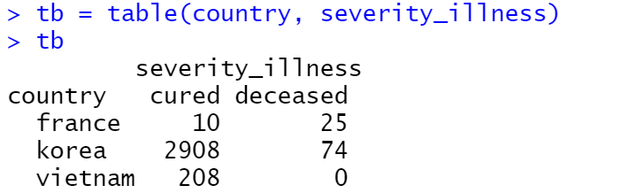

* Chi-quared Test

chisq.test(tb)

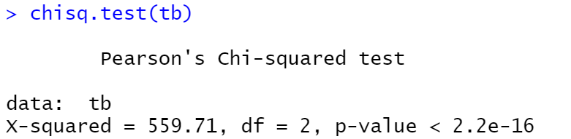

p-value = 2.2e-16 < 0.05 🡪 Reject H0, two categorical variables are dependent.

* 1. Python

**Step 1:** Open Jupyter notebook

* Go to the folder containing the file **Covidpatient.csv** and open **cmd**



* Enter the command “jupyter notebook”

jupyter notebook

* Access the output link in the cmd

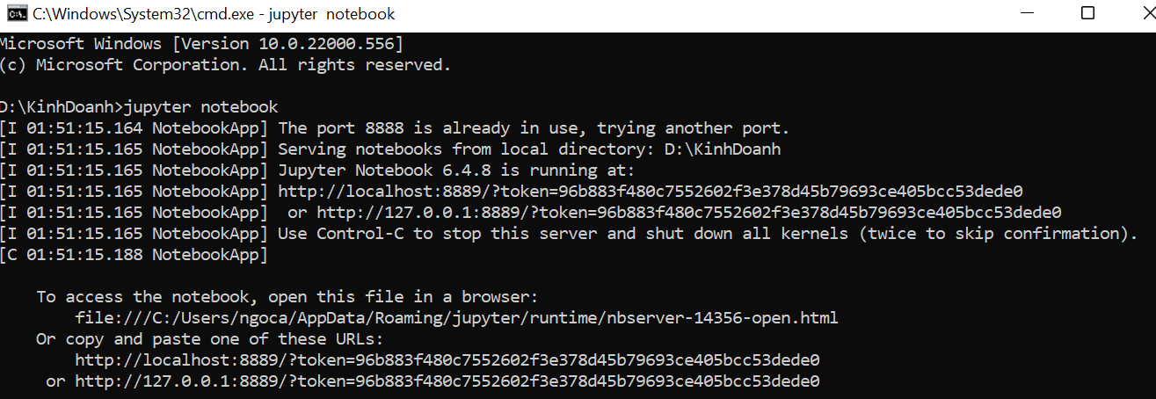

**Step 2:** Create new Python file

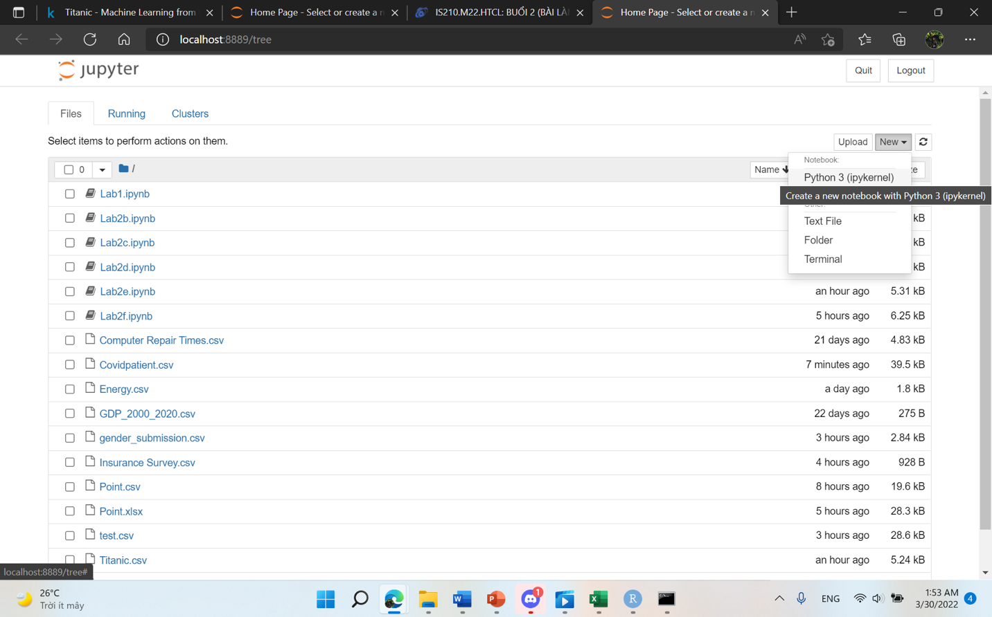

* Select the button **New** and click **Python 3** to create a new file

**Step 3:** Import library

import pandas as pd



**Step 4:** Import **Covidpatient.csv** into the Jupyter

pt = pd.read_csv("Covidpatient.csv")



**Step 5:** Chi-quare Test

chisqt=pd.crosstab(pt.country, pt.severity_illness)

print(chisqt)

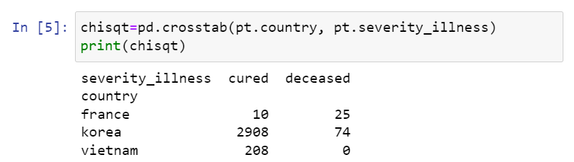

**Step 6:** Import library

import scipy.stats as stats



**Step 7:** p – value

c, p, dof, expected = stats.chi2_contingency(chisqt)

print(p)

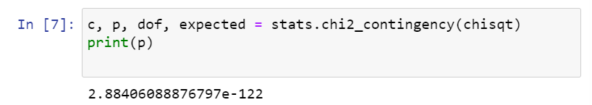

p-value < 0.05 🡪 Reject H0, two categorical variables are dependent.

* 1. MS EXCEL

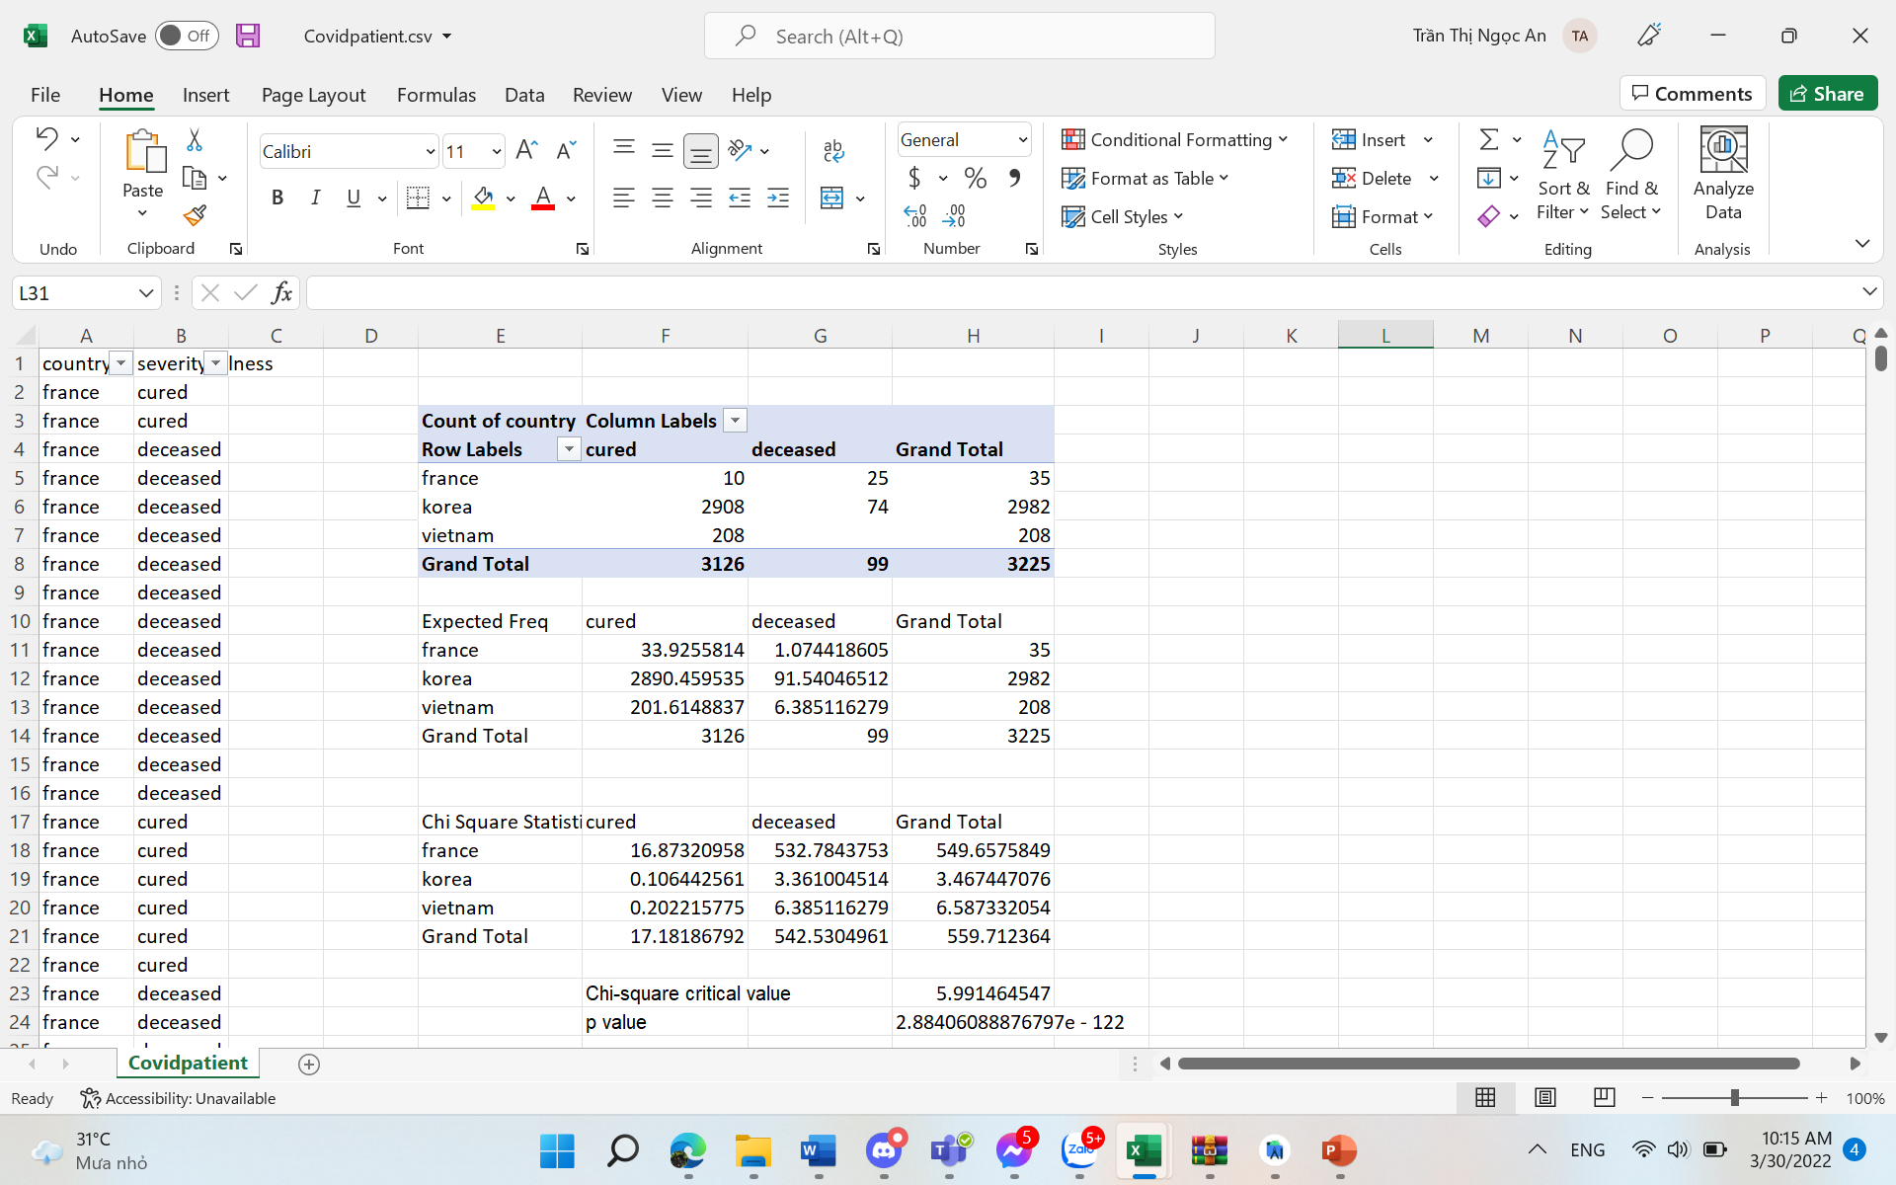

Comment:

* Chi-square Critical value < Chi-square Statistic (5.99 < 559,712) => Reject H0, two categorical variables are dependent.
* Or (p value): p value = 2,88e-122 < 0.05 🡪 Reject H0, two categorical variables are dependent.

**Conclusion:** Based on the results of the Chi-quare test. We can see that Illness severity and country are dependent on each other.

They depend on each other because each country will have different policies in the prevention of covid 19. That leads to different survival and death rates in each country.

This data also shows whether the control measures in those countries have been effective or not. What do they need to pay attention to to reduce the death rate and increase the survival rate

For example, Vietnam, when we look at the data, we can see that the number of deaths here is very low (almost none) and the number of people who have been cured is very high. This shows that Vietnam has applied very effective measures to prevent and control COVID-19.

REFERENCES

1. James R.Evans, “Chapter 7: Statistical Inference” from “Business Analytics: Methods, Models, and Decisions, 1st edition”. [Online]. Link: <https://courses.uit.edu.vn/pluginfile.php/323175/mod_folder/content/0/Ch7-Statistical%20Inference-T.pptx?forcedownload=1>
2. Associate Professor Ph.D Nguyễn Đình Thuân, “Bai giang Phan tich du lieu kinh doanh”, 09/2017. [Online]. Link: <https://courses.uit.edu.vn/mod/resource/view.php?id=130681>
3. Nguyễn Minh Nhựt, “LAB02_PYTHON_2532022.pdf”. [Online]. Link: <https://bitly.com.vn/xrrt6s> [Last updated: 25/03/2022].
4. “Levene Test for Equality of Variance” from “Engineering Statistic Handbook, 1.3.5.10”. [Online]. Link: <https://www.itl.nist.gov/div898/handbook/eda/section3/eda35a.htm>
5. “Tukey’s method” from “Engineering Statistics Handbook, 7.4.7.1” [Online]. Link: <https://www.itl.nist.gov/div898/handbook/prc/section4/prc471.htm>
6. Zach, “How to Perform Levene’s Test in Excel”, 01/04/2020. [Online]. Link: <https://www.statology.org/levenes-test-excel/>
7. Zach, “How to Perform a Tukey-Kramer Post Hoc Test in Excel”, 27/07/2020. [Online]. Link: <https://www.statology.org/tukey-kramer-post-hoc-test-excel/>
8. General Statistics Office of Vietnam, Link: [https://www.gso.gov.vn/px-web-2/?pxid=V1015&theme=Giáo%20dục](https://www.gso.gov.vn/px-web-2/?pxid=V1015&theme=Gi%C3%A1o%20d%E1%BB%A5c)
9. Kaggle, Link: <https://www.kaggle.com/datasets/shirmani/characteristics-corona-patients?select=Characteristics_Corona_patients+version+5+06122020.csv>